PROPOSAL

For

SmartQEye Coastal

Development, Deployment and Commissioning of AI-Based Coastal Drone Surveillance and Video Analytics Software

To

Kerala Police Department

Cyber Division – Drone Forensic Lab
Government of Kerala

Submitted By

Quantumweave Intelligence Private Limited
Thiruvananthapuram, Kerala, India

Submitted On
September 30, 2026

Executive Summary
Quantumweave Intelligence proposes SmartQEye Coastal, an AI-based coastal drone surveillance and maritime intelligence platform for the Kerala Police requirement for the Development, Deployment and Commissioning of AI-Based Coastal Drone Surveillance and Video Analytics Software. SmartQEye Coastal is conceived as a complete operational platform rather than as a standalone computer-vision model. The system will receive and analyse live and recorded UAV video, process RGB/EO and thermal imagery, integrate available drone telemetry and geographical information, detect and track persons, vehicles, boats, vessels and other configured objects, identify operationally relevant events, generate alerts, preserve associated evidence and present actionable information through a secure centralized web-based monitoring environment.
The proposed platform addresses the complete functional scope of the RFP, including object detection and classification, person detection and counting, vehicle detection and tracking, vessel and boat detection, continuous and multi-object tracking, crowd detection and counting, restricted/geofenced-area monitoring, intrusion detection, suspicious or abandoned-object detection, loitering and abnormal-activity analysis, object and vessel behaviour analysis, telemetry association, location-based alerts, thermal/night analytics and event recording. It will support live-stream and recorded-video analysis, HD/Full-HD and higher-resolution inputs, extraction of relevant event clips, secure storage of analytical results and evidence, and scalable processing aligned with the requirement for a minimum of twenty concurrent drone video feeds.
SmartQEye Coastal builds on an existing Quantumweave technology foundation rather than beginning as a greenfield concept. Quantumweave Intelligence has already developed and demonstrated a drone-video analytics solution for Kerala Police, providing practical engineering experience in UAV video ingestion, object/person/vehicle analytics, tracking, surveillance workflows and technical demonstrations. As part of that work, QWI designed and developed a distributed architecture comprising UAV/GCS connectivity, an associated edge laptop, video-ingestion components, centralized GPU-processing components and evidence-management services. SmartQEye Coastal builds on this experience while extending it for coastal operations, RGB/thermal analytics, persistent contact intelligence, centralized monitoring and the broader requirements of the present RFP.
The coastal platform also builds upon QWI's earlier maritime-surveillance research and prototype development, which provide relevant foundations in persistent maritime contact management, temporal and context-aware behaviour analysis, relationships among multiple contacts, evidence provenance, operator-attention prioritization and resilient edge processing. These capabilities are extended specifically for Kerala Police coastal operations and combined with drone-video analytics, GIS and telemetry integration, centralized monitoring, evidence management and flexible deployment across central and edge environments.
SmartQEye Coastal is designed around the realities of Kerala's coastal environment. Surveillance may involve mechanised and motorised fishing vessels, traditional and very small craft, harbours, fish-landing areas, beaches, estuaries, waterways, vehicles and persons near the shoreline, together with substantial legitimate tourism and water-sports activity. Generic anomaly detection alone can therefore create unnecessary alerts because vessel clustering, repeated manoeuvres, shoreline approaches, prolonged low-speed operation or rapid recreational movements may be normal in one operational context and worthy of closer examination in another. The proposed Kerala Coastal Context Intelligence will therefore interpret behaviour using persistent contact history together with GIS zone, time, season, mission profile and police-defined operational context. Hierarchical vessel classification will also retain broader classes such as small craft or unknown vessel where aerial imagery does not support reliable fine-grained classification.
The principal intelligence flow is:
Drone RGB/Thermal Video and Telemetry → Cognitive Frame Selection → AI Detection and Multi-Object Tracking → Persistent Coastal Contact → Kerala Coastal Context Intelligence → Temporal and Cross-Contact Behaviour Intelligence → Context-Aware Operational Attention / Event Decision → Cognitive Keyframe Extraction → GIS-Linked Alerting and Evidence Package → Human Police Interpretation.
QWI's existing Cognitive Frame Selection approach will be extended and adapted for the proposed coastal RGB/thermal environment. It will reduce unnecessary high-cost inference by identifying frames and temporal windows that warrant deeper processing, which is particularly important for multi-feed operation and resource-constrained edge hardware. Cognitive Keyframe Extraction performs a different function: after a meaningful event or contact-state transition has been identified, it selects representative visual evidence for rapid operator review, alert presentation and evidentiary preservation.
A central intelligence concept is the Persistent Coastal Contact. Rather than treating a detected vessel or object merely as a transient bounding box or short-lived tracker identifier, SmartQEye Coastal will maintain an evolving contact record containing relevant observations, movement history, zone interactions, behavioural events, RGB/thermal evidence, available telemetry and observable relationships with other contacts. Temporal intelligence can therefore examine prolonged presence, loitering, repeated shoreline approaches, recurring zone entry, changes in course or speed and unusual stationary behaviour. Cross-contact intelligence can preserve observations such as repeated convergence, prolonged proximity, co-travel or recurring co-appearance without automatically interpreting them as criminal coordination. Operational and legal interpretation will remain with authorized Kerala Police personnel.
RGB and thermal imagery will initially be treated as complementary but distinct sensing modalities. Separate RGB and thermal models will be developed and validated, with their outputs correlated using timestamps, telemetry, tracking and Persistent Coastal Contact information. The architecture will not assume that RGB and thermal feeds are perfectly synchronized, pixel-aligned or identical in resolution, frame rate or field of view. Where the designated UAV payload exposes suitable calibration and synchronization information, deeper cross-sensor association can subsequently be introduced. This approach reduces implementation risk while allowing thermal imagery to complement RGB observations during night-time or reduced visible-light conditions.
SmartQEye Coastal will follow a modular, model-independent and licence-conscious AI strategy. The production platform will not be made dependent on Ultralytics YOLO models such as YOLOv8 or later Ultralytics releases unless an appropriate production licence is specifically approved. This is not a limitation of YOLO as a detection technology; it is a deliberate long-term sustainability and compliance decision. Ultralytics distributes its YOLO software and trained models under AGPL-3.0 by default and provides an Enterprise Licence for private/proprietary deployment. For a police surveillance platform intended for controlled government infrastructure, edge deployment and multi-year maintenance, avoiding an unnecessary mandatory dependency on such licensing reduces potential compliance obligations, recurring commercial-licence expenditure and vendor lock-in.
SmartQEye Coastal will instead prioritize technically suitable detector architectures with permissive licences and clear provenance, including RTMDet/MMDetection and RT-DETR/RT-DETRv2, together with detector-independent tracking such as ByteTrack, subject to performance validation on representative Kerala coastal data. The detector remains a replaceable component within the wider SmartQEye Coastal architecture, allowing future models to be evaluated and introduced without redesigning the tracking, Persistent Coastal Contact, behaviour-intelligence, GIS, evidence or centralized dashboard layers.
The primary technology contribution of SmartQEye Coastal therefore lies not in an individual detector, but in the Kerala-specific dataset and model adaptation, small-object aerial processing, Cognitive Frame Selection, Persistent Coastal Contact Intelligence, temporal and cross-contact behaviour analysis, Kerala Coastal Context Intelligence, Context-Aware Operational Attention, Cognitive Keyframe Extraction, evidence provenance and controlled model lifecycle. Individual detection or tracking models can be replaced or upgraded without redesigning the complete operational platform.
The RFP requires a centralized platform, and SmartQEye Coastal will therefore maintain centralized monitoring, GIS, alerts, historical events, evidence, reporting, user management, model governance, system health and auditability irrespective of where AI processing is performed. The compute architecture supports multiple deployment configurations. For full-scale and multi-feed operation, video and telemetry may be forwarded through the field/GCS gateway to centralized GPU infrastructure for high-performance AI processing. Alternatively, for single or limited-feed missions, bandwidth-constrained locations or post-mission analysis, the field laptop can execute the configured SmartQEye Coastal analytics locally and synchronize alerts, contact metadata, keyframes, selected clips and evidence with the centralized platform. Cooperative use of authorized edge resources may additionally support suitable batch or overflow workloads, while onboard UAV edge processing remains a future/UAV-dependent option where compatible hardware is available.
In the Local Edge Processing with Central Synchronization model, a dedicated central GPU server is not required for AI inference. The field laptop performs the analytics profile validated for its available hardware, while the centralized system consolidates alerts, GIS information, evidence, historical records, reporting, user management and audit. Synchronization may occur in real time, near real time or after a delay depending on connectivity. The actual number and resolution of streams supported by an edge laptop will be established through benchmarking on the designated hardware rather than assumed in advance.
To enable development, integration and model adaptation to commence before the final production infrastructure is fully designated and provisioned, the initial development environment may, subject to Kerala Police approval and applicable data-security requirements, operate for approximately the first three months in a secure QWI-managed environment. Authorized prerecorded coastal drone footage supplied or approved by Kerala Police may be used during this phase for RGB/thermal model adaptation, tracking, behaviour analysis, GIS and telemetry integration, evidence workflows and centralized dashboard layers validation. If operational footage is not permitted outside Kerala Police-controlled infrastructure, the same development stack can instead be deployed within infrastructure designated by the Department. Following this phase, the validated platform will be deployed or migrated to the final Kerala Police-approved production environment and integrated with the designated UAV/GCS and telemetry systems for live-feed validation, acceptance and commissioning.
The centralized operational dashboard will provide multi-UAV video visualization, simultaneous GIS and video display, UAV location and flight information, AI overlays, real-time alerts, GPS/location-associated events, historical search and playback, configurable surveillance zones and geofences, event history, analytics reports, user and role management and system-health monitoring. Significant events can generate an Evidence-Linked Incident Record containing relevant clips, Cognitive Keyframes, Persistent Coastal Contact history, telemetry, GIS context, alert information, operator actions and applicable model/software versions. Security controls will include Role-Based Access Control (RBAC), authentication and authorization, secure administrative access, secure storage and communications, controlled access to live and archived video, audit trails, backup/recovery mechanisms and secure API authentication.
Model development and operational improvement will follow a controlled lifecycle. Suitable public or appropriately licensed maritime and thermal datasets may be used as development baselines, followed by authorized Kerala Police coastal footage for local vessel adaptation, difficult-example mining, threshold calibration, false-alert reduction and formal performance evaluation. Operator feedback may contribute to curated datasets and controlled retraining, but it will not automatically modify deployed models. Dataset versions, model versions, validation results and deployment status will remain traceable throughout the lifecycle.
Deployment and acceptance will progress from coastal-specific development and controlled validation through authorized local-data adaptation, designated UAV/GCS integration, production deployment, functional and performance testing, applicable security testing, live drone-feed analytics demonstration and final acceptance. The proposed implementation period is 16 weeks from project commencement/work order, subject to timely availability of the designated interfaces, representative authorized footage and required deployment infrastructure. The project will subsequently enter the RFP-required minimum three-year support and maintenance period, covering corrective maintenance, software updates, agreed AI-model improvements, integration support, performance monitoring, security updates and remote/on-site assistance as required.
In summary, SmartQEye Coastal transforms RGB and thermal UAV surveillance from isolated frame-level detections into persistent, context-aware and evidence-linked coastal intelligence tailored to Kerala's fishing, tourism, harbour, beach, estuarine and near-shore operating environments. The platform combines QWI's existing Kerala Police drone-analytics foundation with maritime perception, replaceable AI models, Cognitive Frame Selection, Persistent Coastal Contacts, temporal and relational behaviour intelligence, Kerala-specific operational context, Cognitive Keyframe Extraction, GIS and telemetry integration, evidence-oriented incident management, controlled model improvement and a centralized yet compute-flexible deployment architecture. The proposed approach is intended to provide Kerala Police with the functionality required by the RFP while supporting long-term maintainability, transparent model and software provenance, controlled technology evolution and future expansion without redesigning the complete platform.

Contents

Executive Summary 2
1. ORGANIZATION / COMPANY PROFILE 8
1.1 About Quantumweave Intelligence Private Limited 8
1.2 Core Technical Capabilities Relevant to the Project 9
2. PREVIOUS EXPERIENCE IN SIMILAR PROJECTS 9
2.1 Kerala Police — AI-Based Drone Video Analytics 9
2.2 SmartQEye and CrowdEye — CCTV Surveillance, Crowd Monitoring and Behaviour Analytics 10
2.3 Maritime Surveillance and Coastal Analytics Technology Development 11
2.4 Maruti Suzuki — ShowroomX Multi-Camera Video Analytics PoC 13
2.5 Surveillance, UAV and Edge-AI Research and Engineering Foundation 13
2.6 Relevance of Previous Experience to SmartQEye Coastal 14
3. INTRODUCTION 14
3.1 SUMMARY OF THE PROPOSAL 15
4. PROJECT OBJECTIVES 16
5. SCOPE OF THE PROJECT 18
5.1 FUNCTIONAL REQUIREMENTS 21
5.2 NON-FUNCTIONAL REQUIREMENTS 26
6. PROPOSED SOLUTION 30
6.1 SmartQEye Coastal — Solution Overview 30
6.2 End-to-End Solution Architecture 30
6.3 Intelligence Processing and Coastal Analytics 32
6.4 GIS, Telemetry, Alerts, Evidence and Centralized Monitoring 33
6.5 AI Model, Dataset and Technology Strategy 34
6.6 Deployment and Compute Architecture 35
6.6.1 Centralized GPU Processing with Field/GCS Gateway 36
6.6.2 Local Edge Processing with Central Synchronization 38
6.6.3 Cooperative Edge Processing 40
6.6.4 UAV-Onboard Edge Processing and Cellular Connectivity 41
6.6.5 Comparative Assessment and Recommended Deployment Strategy 42
6.7 API, Security and System Governance 44
6.8 Development Environment and Production Transition 46
7. IMPLEMENTATION STRATEGY 47
7.1 TECHNICAL APPROACH 48
7.2 DELIVERABLES / MILESTONES 49
7.3 KEY BENEFITS TO BE ACHIEVED 49
7.4 PROJECT SCHEDULE 50
7.5 SUPPORT REQUIRED FROM KERALA POLICE 51
ANNEXURE A — RFP COMPLIANCE MATRIX 53
A.1 Objectives and Scope Compliance 53
A.2 Coastal Drone AI Analytics Compliance 54
A.3 Video and Data Processing Compliance 54
A.4 Centralized Monitoring Dashboard Compliance 55
A.5 Alert and Event Management Compliance 55
A.6 GIS and UAV Telemetry Compliance 56
A.7 API and System Integration Compliance 56
A.8 Security, Access Control and Data Protection Compliance 56
A.9 AI Model and Analytics Management Compliance 57
A.10 Deployment, Testing and Commissioning Compliance 57
A.11 Training, Documentation and Support Compliance 58
A.12 Deliverables Compliance 58
A.13 Acceptance Criteria Compliance 59
ANNEXURE B - VALIDATION AND ACCEPTANCE MATRIX 60
ANNEXURE C — PROJECT TEAM AND RESPONSIBILITY MATRIX 63
C.1 Project Team Structure 63
C.2 Responsibility Matrix 63
C.3 Project Governance 64
C.4 Knowledge Transfer and Continuity 64

1. ORGANIZATION / COMPANY PROFILE

1.1 About Quantumweave Intelligence Private Limited
Quantumweave Intelligence Private Limited is a Kerala-based deep-technology company incorporated on 18 November 2023, with its operations headquartered in Thiruvananthapuram. The company develops indigenous solutions in Artificial Intelligence, computer vision, intelligent surveillance, drone and edge analytics, cybersecurity, secure digital infrastructure, behavioural intelligence, data privacy and explainable decision-support systems. Its technology development approach combines applied AI/ML research with deployment-oriented software engineering, secure APIs, cloud/edge architectures, GIS-enabled platforms, operator dashboards and controlled model-management workflows.
The company is DPIIT-recognised and is associated with the Kerala startup and national deep-technology ecosystem through programmes and incubation relationships involving Kerala Startup Mission, C3iHub IIT Kanpur, Maker Village, NSRCEL IIM Bangalore, STPI and MeitY initiatives. Quantumweave Intelligence has also received recognition through programmes including DRDO Dare to Dream 5.0, MSME Idea Hackathon, Hack IIT Kanpur, MeitY Cyber Security Grand Challenge and Startup Maharathi, reflecting its continuing work across AI, cybersecurity, surveillance and emerging technology domains.
Quantumweave Intelligence is led by Prof. Sabu M. Thampi, Founder and Managing Director, whose academic and research background spans artificial intelligence, cybersecurity, intelligent surveillance, cognitive systems, secure communications, Internet of Drones and cyber-physical systems. The company's development activities are supported by a multidisciplinary team working across computer vision, machine learning, backend and frontend engineering, cloud/edge deployment, cybersecurity, API development and intelligent analytics.
The company has built a portfolio of AI and cybersecurity technologies including SmartQEye, CrowdEye, SecureSky, QAPIShield, LiveGuard, ShowroomX and other domain-specific intelligent systems. For the present proposal, the most relevant capabilities are SmartQEye/CrowdEye-based surveillance analytics, drone-video processing, temporal and behavioural analysis, Cognitive Frame Selection, Cognitive Keyframe Extraction, multi-object tracking, edge AI, secure deployment, evidence-oriented workflows and operator-facing dashboards.
Quantumweave Intelligence's technology-development model places emphasis on indigenous software development, modular architecture, open and permissively licensed technology components where suitable, secure deployment and controlled technology evolution. For long-term government deployments, this approach reduces unnecessary dependence on proprietary AI-model vendors and allows the system to be maintained, retrained and upgraded according to user-agency requirements.
The company has a substantial research and intellectual-property foundation relevant to the proposed project. Its leadership and research network have contributed to work in cognitive surveillance, crowd behaviour analysis, informative-frame extraction, anomaly detection, multisensor intelligence, UAV systems, secure drone communications and edge/security architectures. Existing research and patent activity provide a technical foundation for advanced capabilities such as behavioural intelligence, Cognitive Frame Selection, Cognitive Keyframe Extraction and evidence-oriented surveillance workflows.

1.2 Core Technical Capabilities Relevant to the Project
Quantumweave Intelligence has in-house capability across the principal technology areas required for the proposed SmartQEye Coastal platform. These include AI-based object detection and classification, person and vehicle analytics, aerial and drone-video processing, multi-object tracking, behavioural and temporal analytics, geofencing, GIS integration, real-time alerting, evidence extraction, historical video analysis, secure dashboards, API integration, model retraining and version management, edge deployment and centralized GPU-based processing.
The company's surveillance technology has evolved beyond frame-level object detection toward context-aware and evidence-linked intelligence. Existing technology concepts include Persistent Contact representation, Cognitive Frame Selection for efficient inference, Cognitive Keyframe Extraction for concise evidence presentation, temporal behaviour analysis, cross-contact relationship analysis and operator-attention prioritization. These capabilities are particularly relevant to the proposed coastal system, where Kerala Police must distinguish routine fishing, tourism and recreational activity from behaviour that warrants closer examination.
Quantumweave Intelligence also has experience designing solutions that can operate across centralized server environments, edge systems and distributed compute architectures. In the earlier Kerala Police drone-video analytics work, the company designed and developed an architecture comprising the drone and Ground Control Station, an associated edge laptop, a dedicated ingestion server and centralized GPU-processing infrastructure. This architecture forms an important engineering foundation for the proposed SmartQEye Coastal Compute Fabric, while the present proposal extends it to include RGB/thermal processing, centralized monitoring, local edge operation and securely coordinated distributed workloads.

2. PREVIOUS EXPERIENCE IN SIMILAR PROJECTS

2.1 Kerala Police — AI-Based Drone Video Analytics
Quantumweave Intelligence's most directly relevant experience is its AI-Based Drone Video Analytics work undertaken for Kerala Police under a formal work order issued in 2026. The engagement involved the development and technical demonstration of a drone-surveillance analytics solution covering UAV-video ingestion, person and object detection, vehicle analytics, multi-object tracking, surveillance-event processing, alert generation and operator-oriented visualization. The work provided Quantumweave Intelligence with direct experience in developing AI-enabled drone-video analytics for Kerala Police requirements and in understanding the operational workflow associated with police drone surveillance.
A key technical component of the solution was the design and development of a distributed drone-video analytics architecture comprising the UAV, Ground Control Station (GCS), field/edge laptop, video-ingestion server, centralized GPU-processing server and evidence-management components. In this architecture, the drone and GCS provide the operational video and telemetry source, while the field laptop acts as the local endpoint associated with the surveillance mission. Video and related data can be handled through the ingestion layer and processed using centralized GPU resources, with analytical outputs and relevant evidence made available through the operator-facing application.
The architecture was designed to separate field acquisition, video ingestion, AI processing, operator interaction and evidence management into modular components. This separation provides flexibility in processing and deployment while allowing the analytics pipeline to evolve independently of the specific UAV or GCS interface. The same architectural approach is directly relevant to the present coastal-surveillance requirement, where multiple drone feeds, centralized monitoring, high-compute AI processing, local edge operation and evidence management must operate together within a common system.
The earlier work also established practical capability in processing drone footage for person, vehicle and object analytics, continuous tracking, event generation and visual presentation of AI outputs. The surveillance pipeline was developed to support operational video-analysis workflows rather than functioning only as an offline research model. This experience is important for the present RFP because the proposed SmartQEye Coastal platform similarly requires integration of AI analytics with live and recorded UAV video, telemetry, GIS information, alerts, evidence and operator workflows.
SmartQEye Coastal builds upon this existing engineering foundation while extending the technology specifically for the coastal and maritime environment. The proposed system introduces boat and vessel analytics, small-craft detection, RGB/thermal processing, Persistent Coastal Contact Intelligence, Kerala Coastal Context Intelligence, temporal and cross-contact behaviour analysis, Cognitive Frame Selection, Cognitive Keyframe Extraction, GIS- and telemetry-linked alerting, evidence-oriented incident management and centralized multi-UAV monitoring.
The previous Kerala Police engagement therefore provides Quantumweave Intelligence with directly relevant experience in UAV video ingestion, aerial computer vision, object/person/vehicle analytics, multi-object tracking, distributed system architecture, GPU-based inference, edge-laptop integration, operator-oriented surveillance workflows and evidence handling. These capabilities substantially reduce the foundational development effort required for SmartQEye Coastal and provide a practical base for extending the solution to the broader functional, thermal, maritime, behavioural and scalability requirements specified in the present RFP.

2.2 SmartQEye and CrowdEye - CCTV Surveillance, Crowd Monitoring and Behaviour Analytics
Quantumweave Intelligence has developed SmartQEye as a broad CCTV-based intelligent surveillance and video analytics platform. The platform provides a technology foundation for automated analysis of surveillance video streams, including person and object detection, tracking, zone-based monitoring, intrusion and loitering analysis, event detection, behavioural interpretation, alert generation, operator dashboards and evidence-oriented review. SmartQEye is designed as a general surveillance analytics framework that can be adapted to different operational environments by configuring object classes, monitoring zones, behavioural rules and analytics modules.
CrowdEye can be considered a specialized crowd-intelligence capability within the broader SmartQEye surveillance framework. While SmartQEye focuses on general CCTV surveillance and video analytics, CrowdEye uses surveillance-video observations and derived analytics specifically for crowd monitoring, crowd counting, crowd formation and movement analysis, behavioural interpretation and prediction of crowd-related situations. CrowdEye was supported under the Startup India Seed Fund Scheme, providing a development pathway for translating the underlying research in crowd surveillance and behaviour analysis into an operational technology platform.
The technical foundation of CrowdEye is closely connected to the Founder's long-standing research in cognitive surveillance, crowd behaviour analysis, intelligent video analytics and behaviour prediction. This work is supported by several years of academic research, peer-reviewed publications and patent applications relating to intelligent crowd monitoring, behavioural analysis, visual attention and surveillance intelligence. The resulting research foundation contributes methods for moving beyond simple person counting toward understanding how crowd activity develops over time and how surveillance information can be prioritized for human operators.
SmartQEye and CrowdEye are directly relevant to the present coastal-surveillance project because several requirements in the Kerala Police RFP originate from conventional surveillance and crowd-video analytics. These include person detection and counting, crowd detection and counting, intrusion monitoring, restricted-zone surveillance, loitering analysis, suspicious or abandoned-object detection, behavioural analytics, configurable alert conditions, event extraction, historical review and operator-oriented monitoring. The existing SmartQEye/CrowdEye technology foundation therefore provides reusable components for the land-side and human-activity elements of SmartQEye Coastal, including beaches, harbour areas, fish-landing locations and other coastal environments where persons, groups and vehicles may need to be monitored in addition to vessels.
A further relevant capability is Cognitive Frame Selection, developed to reduce unnecessary computation by identifying informative frames or temporal windows for deeper analysis rather than applying the most computationally intensive AI models uniformly to every frame. This approach is particularly relevant to SmartQEye Coastal, where multiple simultaneous drone streams, high-resolution aerial imagery and edge-computing constraints can otherwise impose substantial GPU load.
A complementary capability is Cognitive Keyframe Extraction, which selects representative frames around significant events or behavioural transitions for rapid operator review and evidence preservation. Cognitive Frame Selection and Cognitive Keyframe Extraction serve different purposes within the SmartQEye technology family: the former improves computational efficiency during continuous video analysis, while the latter improves the quality and conciseness of evidence presented after an operationally relevant event has been identified.
SmartQEye Coastal extends these CCTV-oriented surveillance and crowd-intelligence foundations into a drone-based coastal environment. The existing person, crowd, vehicle, zone, behaviour and evidence analytics can be combined with maritime-specific vessel detection, RGB/thermal processing, Persistent Coastal Contact Intelligence, GIS and telemetry association and contextual coastal behaviour analysis. In this manner, SmartQEye provides the broader surveillance platform, CrowdEye contributes specialized crowd-intelligence capabilities, and SmartQEye Coastal extends the combined technology foundation into coastal and maritime drone surveillance for Kerala Police.

2.3 Maritime Surveillance and Coastal Analytics Technology Development
Quantumweave Intelligence's work in maritime surveillance predates the present Kerala Police coastal-surveillance requirement and represents a distinct technology-development stream complementing its CCTV-oriented SmartQEye and CrowdEye platforms. An earlier SmartQEye-M maritime prototype was developed in connection with an international maritime AI challenge associated with Safran Electronics & Defense in Singapore. This work explored AI-based maritime object and vessel detection, temporal tracking, behavioural analysis, geofencing, multisensor-oriented processing, Cognitive Keyframe Extraction and operator visualization.
The earlier SmartQEye-M prototype used publicly available maritime datasets and controlled inputs where suitable operational multisensor data were unavailable. Its architecture considered information from EO/RGB imagery, thermal sensing, radar, AIS and optional UAV-derived observations, providing Quantumweave Intelligence with an early engineering foundation in multisource maritime surveillance and contact-oriented analysis. The work was exploratory and prototype-oriented and is not presented as an already completed operational coastal-policing system.
Quantumweave Intelligence's maritime technology development was subsequently strengthened through its participation in the MSME Idea Hackathon 5.0, where the company was selected as a winner under the Maritime Domain Awareness problem area. The proposed maritime surveillance concept under this programme addressed AI-enabled maritime awareness and surveillance requirements and further strengthened the company's work in vessel analytics, multisensor maritime intelligence, coastal surveillance and operational decision-support. This recognition provides additional evidence of Quantumweave Intelligence's continuing technology development in maritime and coastal-security applications and complements the earlier SmartQEye-M prototype work.
This maritime technology development is particularly relevant because surveillance over the sea presents challenges substantially different from conventional CCTV, road or urban video analytics. Boats and small craft may occupy only a small portion of an aerial image, particularly at higher UAV altitudes or greater stand-off distances. Sea state, waves, reflections, glare, haze and changing illumination can affect visual detection, while the appearance of the same vessel can vary significantly according to viewing geometry, range, loading condition and sensor modality. Thermal imagery introduces another set of characteristics and therefore cannot simply be treated as equivalent to visible-light imagery.
Maritime behaviour is also strongly dependent on operational context. Slow movement, prolonged presence, repeated course changes, clustering of small vessels or close proximity between two craft may occur naturally during fishing, harbour operations, tourism or recreational activity. The same observable behaviour may have different significance near a restricted area, monitored landing location or during an unusual time period. Effective coastal analytics therefore requires more than transferring a generic object detector to drone video; it requires persistent observation of contacts, interpretation of behaviour over time and consideration of the geographical and operational context in which that behaviour occurs.
The proposed SmartQEye Coastal platform builds upon this earlier maritime-surveillance foundation and combines it with Quantumweave Intelligence's existing drone-video analytics and broader SmartQEye surveillance capabilities. The present development extends these foundations toward Kerala-specific small-vessel and fishing-craft analytics, aerial small-object detection, dedicated RGB and thermal processing, Persistent Coastal Contact Intelligence, temporal vessel-behaviour analysis, cross-contact relationship intelligence, geospatial and location/time-aware operational context, Cognitive Frame Selection, Cognitive Keyframe Extraction and evidence-oriented alerting and review.
The earlier SmartQEye-M work and the company's subsequent recognition under the MSME maritime-technology programme therefore provide relevant prior experience in maritime perception, tracking, behavioural analysis, multisensor-oriented system design and coastal-domain intelligence. SmartQEye Coastal represents the next stage of this technology evolution, requiring adaptation and validation using representative Kerala coastal drone imagery, actual RGB/thermal payload characteristics, available UAV telemetry and Kerala Police-defined operational zones and surveillance scenarios.

2.4 Maruti Suzuki — ShowroomX Multi-Camera Video Analytics PoC
Quantumweave Intelligence has also undertaken a paid multi-camera computer-vision PoC for Maruti Suzuki under the ShowroomX platform. The work involved processing multiple camera feeds, scheduling analytics workloads, operator dashboards and deployment-oriented video analytics. The PoC value was approximately ₹10.35 lakh. Although the operating environment differs from coastal surveillance, this engagement is relevant to SmartQEye Coastal because it has provided experience in multi-camera orchestration, real-world video ingestion, inference scheduling, dashboard integration and operational analytics. These capabilities are directly useful to the RFP requirement for simultaneous processing and monitoring of multiple drone feeds.

2.5 Surveillance, UAV and Edge-AI Research and Engineering Foundation
Quantumweave Intelligence's engineering capabilities are complemented by the long-standing academic research of its Founder, Prof. Sabu M. Thampi, and his research collaborators in UAV systems, intelligent surveillance, multisensor fusion, edge AI, secure drone communications, GPS-spoofing detection, trajectory prediction, person re-identification and cognitive navigation. This academic research foundation provides relevant scientific and technical knowledge that informs the company's development of secure, context-aware and computationally efficient surveillance systems.
Recent work by the Founder and his academic research collaborators includes the peer-reviewed study “A Robust Autonomous UAV Obstacle Avoidance through Multi-Sensor Fusion and Intelligent Decision-Making,” published in Multimedia Tools and Applications, Springer, in September 2026. The work investigates multisensor fusion, GPS-spoofing detection, interpretable decision-making and computationally efficient UAV navigation. These research themes are relevant to SmartQEye Coastal through their contributions to sensor-aware processing, resilient UAV-linked systems, contextual reasoning and efficient edge analytics.
The Founder's research group is also investigating future trajectory prediction in dynamic aerial-surveillance environments, using spatio-temporal graph and transformer-based approaches for uncertainty-aware prediction of target movement. Related ongoing work examines person re-identification in UAV surveillance, addressing altitude variation, viewpoint changes, occlusion and low-resolution imagery through multimodal and memory-based representations. These research directions provide a scientific foundation for future improvements in persistent tracking and temporal reasoning within aerial surveillance systems.
Another research direction, Cog-GLEN, investigates hierarchical cognitive navigation for UAVs operating in partially observable three-dimensional environments. The work combines persistent spatial memory, cognitive mapping, predictive planning and reinforcement learning. Although autonomous flight control is outside the principal scope of SmartQEye Coastal, the underlying research contributes relevant expertise in partial observability, persistent spatial reasoning and context-aware UAV decision-making.
Quantumweave Intelligence draws upon this broader research foundation while developing its own surveillance, drone-video analytics, edge-processing and operational software platforms. The relationship is therefore complementary: the Founder's academic research and collaborations provide scientific depth and emerging methods, while Quantumweave Intelligence converts selected relevant concepts into deployment-oriented engineering solutions for operational use cases.

2.6 Relevance of Previous Experience to SmartQEye Coastal

SmartQEye Coastal builds on Quantumweave Intelligence's direct project experience, surveillance platforms, maritime analytics work and multi-camera video-processing capability. The earlier Kerala Police drone-video analytics work provides experience in UAV-video ingestion, aerial analytics, tracking and distributed processing; SmartQEye and CrowdEye contribute CCTV surveillance, crowd and behaviour analytics; earlier maritime work provides vessel and coastal-analytics experience; and the ShowroomX PoC contributes multi-stream video processing and deployment experience.

These company capabilities are complemented by the Founder's long-standing academic research with his collaborators in intelligent surveillance, UAV systems, multisensor fusion, trajectory analysis, aerial re-identification and edge AI. Together, they reduce the foundational technical risk of the project and allow the proposed development to focus on the new requirements of this RFP: Kerala-specific small-vessel analytics, RGB/thermal processing, Persistent Coastal Contacts, contextual and cross-contact behaviour intelligence, Cognitive Frame Selection, Cognitive Keyframe Extraction, GIS/telemetry integration, twenty-feed scalability, centralized monitoring and controlled local model adaptation using authorized Kerala Police footage.

3. INTRODUCTION
Kerala Police has envisaged an AI-enabled coastal drone surveillance platform capable of converting live and recorded UAV video, associated telemetry and geographical information into actionable intelligence for coastal policing. The RFP requires a secure and scalable system for analysing multiple drone feeds, detecting and tracking persons, vehicles, boats and vessels, identifying operationally relevant activities, generating location-linked alerts and presenting the resulting information through a centralized web-based monitoring and analytics environment.
The proposed SmartQEye Coastal platform has been conceived specifically for this requirement. It combines Quantumweave Intelligence's existing drone-video analytics experience with its broader surveillance, crowd analytics, maritime analytics and edge-AI capabilities to create a coastal-focused platform capable of processing RGB/EO and thermal imagery, maintaining persistent contact histories, interpreting behaviour within Kerala-specific operational contexts and preserving relevant evidence for police review.
Kerala's coastal environment requires substantially more than generic boat detection. The same surveillance area may contain fishing craft, mechanised vessels, traditional boats, harbour traffic, persons on beaches, vehicles near landing points, swimmers, tourists and recreational watercraft. SmartQEye Coastal therefore combines perception, tracking, temporal behaviour, GIS context and operator-defined rules so that activity is interpreted according to where, when and under what operational conditions it occurs, rather than relying solely on isolated anomaly scores.
The proposed architecture also recognizes the practical need for deployment flexibility. Centralized monitoring, evidence management, GIS, model governance, user management and auditability remain common to the complete system, while AI processing can be performed through centralized GPU infrastructure, authorized edge laptops or securely coordinated distributed compute resources according to operational requirements and available infrastructure.

3.1 SUMMARY OF THE PROPOSAL
SmartQEye Coastal is proposed as a centralized AI-based coastal drone surveillance and maritime intelligence platform for receiving and analysing live and recorded UAV video, integrating available telemetry and GIS information, performing AI-enabled detection and tracking, generating configurable alerts and maintaining searchable event and evidence records. The platform is designed to satisfy the complete functional requirements of the RFP, including support for multiple UAV platforms, person and vehicle analytics, boat and vessel detection, multi-object tracking, crowd monitoring, geofencing, intrusion detection, suspicious or abandoned objects, loitering and abnormal activity, vessel-behaviour analysis, telemetry association, location-based alerts, thermal/night analytics and event recording.
The proposed intelligence pipeline is:
Drone RGB/Thermal Video and Telemetry → Cognitive Frame Selection → AI Detection and Multi-Object Tracking → Persistent Coastal Contact → Kerala Coastal Context Intelligence → Temporal and Cross-Contact Behaviour Intelligence → Context-Aware Operational Attention / Event Decision → Cognitive Keyframe Extraction → GIS-Linked Alerting and Evidence Package → Human Police Interpretation.
The platform introduces a Persistent Coastal Contact abstraction so that detected vessels and other objects are not treated merely as frame-level bounding boxes or temporary tracker IDs. Their observations, movement history, zone interactions, behaviour, relevant RGB/thermal evidence and relationships with other contacts can be accumulated over time. This enables the system to identify patterns such as prolonged presence, repeated shoreline approaches, recurring zone entry, vessel-to-vessel proximity and other observable behavioural sequences while leaving operational interpretation to authorized police personnel.
A core feature is Kerala Coastal Context Intelligence, which allows behaviour to be interpreted according to geographical zone, time, season and operational profile. This is particularly important in Kerala, where legitimate fishing, harbour, tourism and water-sports activity can otherwise generate large numbers of false alerts. The system can therefore apply different operational profiles to fishing areas, beaches, tourism zones, harbours, landing locations, estuaries and restricted areas.
RGB and thermal imagery will initially be processed through separate but complementary AI models, with outputs correlated using timestamps, telemetry, tracking and contact history. The production AI stack will prioritize permissively licensed and replaceable model architectures so that Kerala Police is not unnecessarily tied to recurring third-party detector licensing or a single AI-model vendor. Kerala-specific RGB and thermal models will be progressively trained and validated using authorized coastal footage, with controlled dataset and model version management.
SmartQEye Coastal will support the RFP requirement for a minimum of twenty concurrent drone feeds through Cognitive Frame Selection, adaptive inference scheduling and resource-aware multi-stream orchestration. The platform will provide centralized monitoring and management while supporting three complementary processing modes: centralized GPU processing for high-throughput analytics, edge-laptop processing for local/live or post-mission analysis, and a Secure Cooperative Edge Compute Pool for suitable overflow and batch workloads.
During the initial development and model-adaptation phase, the platform may, subject to Kerala Police approval and applicable data-security requirements, be hosted temporarily in a secure QWI-managed cloud environment using authorized pre-recorded coastal drone footage. If such footage cannot leave Kerala Police-controlled infrastructure, the same development stack can be deployed within infrastructure designated by the Department. The validated platform will subsequently be migrated or deployed to the final Kerala Police-designated environment and integrated with the designated UAV/GCS and telemetry systems for live-feed testing, acceptance and commissioning.
The proposed system will also provide the centralized web-based dashboard, GIS/video visualization, alert and event management, historical search and playback, RBAC, audit logging, secure APIs, model management, system-health monitoring, training, documentation and minimum three-year support required by the RFP.

4. PROJECT OBJECTIVES
The primary objective of the project is to develop, deploy and commission SmartQEye Coastal, a secure and scalable AI-based coastal drone surveillance and maritime intelligence platform capable of transforming live and recorded UAV video, associated telemetry and geographical information into actionable intelligence for Kerala Police. The platform will provide a centralized operational environment for monitoring and management while allowing AI workloads to be executed through appropriately provisioned central and edge computing resources. This directly addresses the RFP objective of establishing a centralized AI-enabled platform for analysing coastal drone feeds, integrating telemetry and location information, generating real-time alerts and presenting actionable information through a secure web-based monitoring dashboard.
The project will develop and integrate AI analytics for persons, vehicles, boats, vessels and other configured objects, together with person counting, vehicle and vessel tracking, continuous and multi-object tracking, crowd detection and counting, restricted/geofenced-area monitoring, intrusion detection, suspicious or abandoned-object detection, loitering and abnormal-activity analysis, object and vessel behaviour analysis, telemetry association, location-based alerts, thermal/night analytics and event recording. The proposed analytics will be optimized progressively for aerial and coastal surveillance and will support addition of new object classes and Kerala-specific vessel categories as suitable authorized datasets become available.
A major objective is to extend conventional frame-level video analytics into Persistent Coastal Contact Intelligence. Rather than treating a detected vessel or object only as a temporary bounding box or tracker ID, the platform will maintain an evolving contact history containing observations, movement, zone interactions, behavioural events, relevant RGB/thermal evidence, available telemetry and observable relationships with other contacts. This will enable temporal interpretation of patterns such as prolonged presence, loitering, repeated shoreline approaches, recurring zone entry, changes in course or speed and unusual stationary behaviour.
The project will also develop Kerala Coastal Context Intelligence so that observed behaviour is interpreted in relation to geographical location, time, season, mission profile and police-defined operational context. Fishing areas, harbours, fish-landing centres, beaches, tourism and water-sports zones, estuaries, waterways and restricted areas can exhibit very different legitimate activity patterns. SmartQEye Coastal will therefore support configurable operational zones, thresholds, time conditions, alert sensitivity, priority/severity levels and notification/escalation parameters so that operator attention is directed according to context rather than through a universal anomaly threshold.
The project will incorporate Cognitive Frame Selection to optimize compute utilization across continuous and multi-feed surveillance. Informative frames and temporal windows can receive deeper AI processing while repetitive or low-activity periods are handled at reduced processing intensity. After an operationally relevant event or contact-state transition is identified, Cognitive Keyframe Extraction will select concise representative visual evidence for rapid operator review and evidentiary preservation. These two capabilities will respectively support efficient inference and effective evidence presentation.
Another objective is to provide scalable processing capable of meeting the RFP requirement for a minimum of twenty concurrent drone video feeds, expandable according to operational requirements. SmartQEye Coastal will use resource-aware inference scheduling and a flexible compute architecture that can employ centralized GPU resources, validated edge-laptop processing and, where authorized, securely coordinated distributed resources. Regardless of where individual workloads are executed, relevant operational outputs, alerts, event metadata, contact information, evidence and system status will remain available through the centralized SmartQEye Coastal platform.
The project will provide comprehensive GIS and UAV telemetry integration, associating available GPS coordinates, altitude, heading, ground speed, flight status, drone identification and mission/flight information with video and detected events. The centralized monitoring interface will provide simultaneous map and video visualization, drone location and trajectory display, configured surveillance zones and location-associated alerts. Where the designated UAV platform provides the required camera/gimbal pose and calibration information, the platform may additionally support enhanced target or event geolocation beyond the mandatory telemetry and GIS association.
The project will establish an evidence-oriented and auditable event-management workflow in which significant events can generate structured incident records containing relevant clips, Cognitive Keyframes, AI overlays, contact history, available telemetry, GIS context, alert rationale, operator actions and applicable model/software versions. All generated alerts and subsequent authorized user actions will be recorded in an audit trail. Security controls will include RBAC, authentication and authorization, secure administrative access, secure storage and communication, controlled access to live and archived video, configurable permissions, backup and recovery and secure API authentication.
The project will establish a controlled AI model and dataset lifecycle supporting addition of new object classes, authorized retraining and fine-tuning, dataset management, model version management, performance evaluation and deployment of validated model updates without major modification of the core platform. The production AI architecture will prioritize replaceable and deployment-friendly model components so that the system can evolve during its operational lifecycle without unnecessary dependence on a single detector or model vendor.
Finally, the project will progress through coastal-specific development, controlled validation, authorized local-data adaptation, designated UAV/GCS integration, deployment, configuration, functional and performance testing, applicable security testing, live drone-feed analytics demonstration, acceptance testing and commissioning. The project will also provide operator and administrator training, technical and user documentation, API documentation, required software licences where applicable, and a minimum three-year comprehensive support and maintenance period, extendable based on Kerala Police requirements.

5. SCOPE OF THE PROJECT
The scope of SmartQEye Coastal covers the development, supply, deployment, integration, testing, commissioning and operationalization of a complete AI-based coastal drone surveillance software platform for Kerala Police. The solution will support live and recorded video from compatible UAV platforms, available drone telemetry, RGB/EO and thermal sensing, AI-based detection and tracking, coastal and maritime behaviour analytics, GIS visualization, alert and event management, evidence handling, centralized monitoring, cybersecurity, API integration, model management, training and lifecycle support. This is aligned with the complete scope specified in the RFP.
The video and sensor-processing scope includes live video streaming, recorded-video analysis and support for commonly used formats including MP4, MOV, AVI and MKV. The platform will support HD, Full-HD and higher-resolution inputs and will be capable of processing a minimum of twenty concurrent drone video feeds, with provision for expansion according to operational requirements. Relevant event clips will be extracted and stored along with associated metadata and evidence.
The AI analytics scope includes detection and classification of persons, vehicles, boats, vessels and other configured objects; person detection and counting; vehicle detection, classification and tracking; vessel/boat detection, classification and tracking; continuous object tracking; crowd detection and counting; restricted/geofenced-area monitoring; intrusion detection; suspicious or abandoned-object detection; loitering and abnormal-activity analysis; object and vessel behaviour analysis; simultaneous multi-object tracking; telemetry association; location-based alerts; thermal/night analytics; and recording and preservation of detected events and associated metadata.
The project will include Kerala-specific coastal analytics for small and visually diverse vessels and craft. A hierarchical classification strategy will be used so that the system can distinguish major operational categories reliably while avoiding unsupported fine-grained classifications when aerial imagery is insufficient. Models will be progressively adapted using authorized coastal imagery to improve performance across fishing craft, traditional boats, mechanised vessels, recreational craft and other locally relevant classes under varying altitude, viewing geometry, illumination, sea-state and sensor conditions.
The persistent contact and behaviour-intelligence scope will extend conventional tracking into Persistent Coastal Contact management. Contact histories will support interpretation of dwell, loitering, repeated shoreline approaches, recurring zone interactions, course and speed changes, stationary behaviour and other configured temporal patterns. Cross-contact analysis will preserve observable relationships such as convergence, prolonged proximity, repeated co-appearance and recurring interaction without autonomously assigning criminal or hostile intent.
The context-intelligence and alert-management scope will allow Kerala Police to configure different operational profiles for fishing areas, harbours, fish-landing centres, beaches, tourism and water-sports zones, estuaries, waterways, restricted areas and other surveillance regions. The platform will support configurable alert types, detection thresholds, geographical zones, time-based conditions, sensitivity, priority/severity levels and notification/escalation parameters. All generated alerts and subsequent authorized user actions will be recorded in an auditable history.
The Cognitive Frame Selection and resource-orchestration scope will optimize processing by dynamically prioritizing frames and streams that require deeper AI analysis. Cognitive Keyframe Extraction will separately select representative visual evidence around significant events for rapid operator review and inclusion in evidence packages. Together with lightweight tracking and resource-aware inference scheduling, these capabilities will support efficient utilization of available central and edge GPU resources.
The GIS and telemetry scope includes integration of available UAV GPS coordinates, altitude, heading, ground speed, flight status, drone identification and mission/flight information. The centralized interface will visualize drone position, trajectory, surveillance area and detected events. Where the designated UAV platform provides suitable camera/gimbal orientation and calibration data, enhanced target/event geolocation may also be incorporated.
The centralized monitoring and dashboard scope includes live visualization of multiple drone feeds, simultaneous GIS and video display, real-time drone location and flight information, AI-detected overlays, real-time alerts, GPS/location-associated event display, search and filtering of historical events, recorded-video and event playback, telemetry display, configurable surveillance zones and geofences, event history, analytics reports, user and role management and system-health monitoring.
The deployment scope will maintain a centralized SmartQEye Coastal platform while allowing flexible placement of AI workloads. Centralized GPU infrastructure will provide the preferred high-throughput processing environment. Authorized field laptops may support validated local live or post-mission analytics, while securely coordinated edge resources may support approved overflow, batch or post-mission workloads. All significant operational outputs generated through edge or distributed processing will be synchronized with the centralized platform so that monitoring, evidence, GIS, user management, model governance, reporting and auditability remain centrally available.
Subject to Kerala Police approval and applicable data-security requirements, the initial development, integration and model-adaptation phase may use a secure QWI-managed development environment with authorized pre-recorded coastal drone footage. Where such footage is required to remain within Kerala Police-controlled infrastructure, the same application stack can be deployed within infrastructure designated by the Department. The validated platform will thereafter be deployed or migrated to the final Kerala Police-designated production environment and integrated with the designated UAV/GCS and telemetry systems for live-feed testing, acceptance and commissioning.
The security and data-protection scope includes RBAC, user authentication and authorization, secure administrative access, secure communications between components, secure storage of surveillance data and analytical results, controlled access to live and archived video, configurable permissions for viewing, analysis, export and administration, audit trails, secure API authentication and backup/recovery mechanisms. The solution will be implemented in accordance with applicable Government of India requirements, policies and directions relating to cybersecurity, data protection, lawful surveillance and handling of digital information.
The integration scope includes RESTful APIs and modular adapters for UAV command-and-control systems, UAV telemetry sources, GIS platforms, authorized Kerala Police operational systems, approved external data sources and future AI or surveillance applications. The integration architecture will remain modular so that compatible UAV platforms and future authorized systems can be incorporated without redesigning the core analytics platform.
The AI model-management scope includes addition of new object classes, authorized model retraining and fine-tuning, dataset management, model version management, performance evaluation and controlled deployment of updated models. Required software licences, where applicable, will be provided and documented as part of the solution. The architecture will support controlled model evolution without requiring major modification of the core platform.
The deployment, testing and commissioning scope includes software installation and configuration, integration with designated drone systems, configuration of video and telemetry inputs, GIS/map services, users and access privileges, AI analytics and the centralized dashboard; functional and performance testing; applicable security testing; demonstration of live drone-feed analytics; acceptance testing; and final commissioning. The system will be considered operational only after successful demonstration and acceptance by the designated authority.
The training and documentation scope includes comprehensive training for nominated Kerala Police personnel covering dashboard operation, live drone-feed monitoring, AI event and alert management, GIS/map-based monitoring, historical video and event analysis, user and access management, system administration, basic AI model/data management where applicable, data export/reporting and troubleshooting. User manuals, administrator manuals, technical documentation and API documentation will form part of the project deliverables.
The support and maintenance scope includes a minimum three-year comprehensive technical support period from successful commissioning, with provision for extension based on Kerala Police requirements. Support will include software bug fixing and corrective maintenance, updates and patches, agreed AI-model improvements, technical troubleshooting, integration support, performance monitoring, security updates, remote and on-site assistance where required, and support during future expansion or integration with compatible UAV platforms.
The project deliverables will include the AI-based coastal drone video analytics software, centralized web-based monitoring dashboard, AI analytics and alert engine, drone-video and telemetry integration modules, GIS/map-based monitoring, user and role management, event and alert management, API/integration interfaces, AI model-management capability, required software licences where applicable, installation and commissioning, user and administrator training, technical and user documentation, system testing and commissioning reports, and warranty/support documentation, in accordance with the RFP.

5.1 FUNCTIONAL REQUIREMENTS
SmartQEye Coastal shall provide the complete functional capability required for AI-enabled coastal drone surveillance, beginning with acquisition of live and recorded UAV video and associated telemetry and extending through AI analytics, tracking, coastal-context interpretation, alert generation, GIS visualization, evidence management, historical investigation and centralized operator monitoring. The solution shall support compatible UAV platforms and shall provide a common operational environment in which video, telemetry, AI-generated information, alerts and evidence can be viewed and managed securely.
5.1.1 Live and Recorded Drone Video Ingestion: The platform shall support ingestion and analysis of both live UAV video streams and recorded surveillance footage. It shall support commonly used video formats including MP4, MOV, AVI and MKV, together with HD, Full-HD and higher-resolution video inputs. The ingestion architecture shall remain modular so that compatible video and telemetry interfaces from different UAV platforms and Ground Control Stations can be incorporated through source-specific adapters without redesigning the core analytics platform. Recorded footage shall use substantially the same analytics pipeline as live surveillance, thereby supporting post-mission analysis, deeper second-pass inference and historical investigation where real-time latency is not required.

5.1.2 RGB/EO and Thermal Video Processing: SmartQEye Coastal shall support both RGB/EO and thermal/night-surveillance imagery. RGB and thermal streams shall initially be treated as complementary but distinct sensing modalities, allowing sensor-specific models and processing configurations to be used according to the characteristics of each payload. The platform shall correlate RGB and thermal observations using timestamps, telemetry, tracking and Persistent Coastal Contact information. Where the designated UAV platform provides suitable calibration, synchronization and camera/gimbal metadata, deeper cross-sensor association may be incorporated. The system shall not depend on perfect pixel-level alignment between RGB and thermal streams for basic operation.

5.1.3 AI-Based Object Detection and Classification: The system shall detect and classify persons, vehicles, boats, vessels and other configured objects of operational interest from aerial coastal imagery and shall display AI-generated bounding boxes and associated analytical information. The platform shall support progressive addition of Kerala-specific coastal classes as suitable authorized data becomes available. A hierarchical classification strategy shall be adopted so that broad and reliable classes such as vessel/boat, small craft or unknown vessel can be retained where image quality does not support a more specific subtype.

5.1.4 Person Detection and Counting: The platform shall automatically detect and count persons from aerial video. Person analytics shall support coastal land-side environments including beaches, tourism locations, harbour surroundings, fish-landing centres and other monitored areas.

5.1.5 Vehicle Detection, Classification and Tracking: SmartQEye Coastal shall detect, classify and track vehicles appearing within the surveillance area. Vehicle analytics shall support coastal roads, harbour areas, fish-landing locations and other operationally relevant land-side areas visible from the UAV.

5.1.6 Vessel and Boat Detection, Classification and Tracking: The platform shall detect, classify and track boats, vessels and other configured watercraft in coastal and maritime areas. Special consideration shall be given to small craft and fishing vessels that may appear as very small aerial targets because of UAV altitude, viewing angle or distance. Model adaptation shall progressively address locally relevant vessel types using authorized Kerala coastal footage.

5.1.7 Continuous and Multi-Object Tracking: The platform shall support continuous tracking of detected moving objects and simultaneous tracking of multiple persons, vehicles and vessels. Short-term tracker outputs shall be available to higher-level analytics for maintaining movement history, calculating dwell and proximity information, detecting zone interactions and supporting Persistent Coastal Contact formation.

5.1.8 Persistent Coastal Contact Intelligence: SmartQEye Coastal shall extend conventional frame-level tracking through a Persistent Coastal Contact representation. A persistent contact may retain current and historical observations, movement history, zone interactions, sensor observations, behavioural events, selected RGB/thermal evidence, available telemetry and observable relationships with other contacts. Where sufficient evidence supports continuity, temporary detector misses, short observation gaps or brief sensor degradation need not automatically destroy the accumulated contact history. Where continuity remains uncertain, the system shall retain that uncertainty rather than forcing an unsupported association.

5.1.9 Crowd Detection and Counting: The platform shall support detection and counting of gatherings from aerial video and shall allow configurable threshold-based crowd alerts. Crowd analytics shall support beaches, tourism areas, public coastal locations, harbour surroundings and other environments where concentrations or movements of people may require monitoring.

5.1.10 Restricted-Zone and Geofence Monitoring: Authorized users shall be able to configure surveillance zones and geofences through the GIS interface. The system shall monitor contacts and configured events in relation to these zones and shall generate alerts when specified conditions occur. Operational zones may include beaches, tourism and water-sports areas, harbours, fish-landing centres, estuaries, waterways, monitored landing areas, patrol sectors, restricted locations and other areas designated by Kerala Police.

5.1.11 Intrusion Detection: The platform shall support detection of unauthorized movement or entry into configured restricted surveillance areas and shall associate the resulting event with the corresponding contact, time, available location information and supporting evidence.

5.1.12 Suspicious or Abandoned Object Detection: SmartQEye Coastal shall support identification of unattended or stationary objects using configurable time-based conditions. Relevant events shall be recorded with associated video/image evidence, location context and metadata.

5.1.13 Loitering and Abnormal-Activity Analysis: The system shall detect prolonged presence, loitering and configured abnormal movement patterns. Where persistent tracking information is available, behaviour shall be evaluated over time rather than solely through independent frame-level detections.

5.1.14 Vessel and Object Behaviour Analysis: The platform shall analyse configurable movement patterns and behavioural indicators for vessels and other tracked objects. Relevant observations may include prolonged presence, dwell, repeated shoreline approaches, recurring entry into configured zones, significant changes in speed or heading, unusual stationary behaviour, repeated approach/departure sequences and other conditions configured by Kerala Police. Behavioural outputs shall represent observable activity and shall not autonomously assign criminal or hostile intent.

5.1.15 Cross-Contact Relationship Intelligence: SmartQEye Coastal shall support analysis of observable relationships among multiple persistent contacts. The system may identify repeated convergence, prolonged proximity, recurring co-appearance, co-travel, separation and reappearance, sequential interaction with the same monitored area and other configured spatial-temporal relationships. Such relationships shall be presented as supporting operational information for authorized police interpretation rather than as automatic conclusions regarding coordination or intent.

5.1.16 Kerala Coastal Context Intelligence: The platform shall interpret detected activity in relation to geographical location, time, season, mission profile and police-defined operational context. Different context profiles may be configured for fishing zones, harbours, fish-landing centres, beaches, tourism and water-sports locations, estuaries, waterways, restricted zones and other operational areas. This capability shall allow the same observable movement to be treated differently according to its legitimate local context and shall help reduce unnecessary alerts arising from normal fishing, harbour, tourism or recreational activity.

5.1.17 Cognitive Frame Selection: SmartQEye Coastal shall incorporate Cognitive Frame Selection to optimize AI processing across continuous video streams. Instead of applying the most computationally expensive inference uniformly to every incoming frame, the mechanism shall prioritize frames or temporal windows containing meaningful changes such as new objects, significant motion, track uncertainty, zone interaction, scene variation or other operational cues. This capability shall support efficient utilization of central and edge GPU resources and shall contribute to multi-feed scalability.

5.1.18 Cognitive Keyframe Extraction: Following identification of a significant event or contact-state transition, Cognitive Keyframe Extraction shall select representative visual frames for rapid operator review and inclusion within event and evidence records. Cognitive Frame Selection and Cognitive Keyframe Extraction shall remain distinct capabilities: Cognitive Frame Selection optimizes computational workload, while Cognitive Keyframe Extraction provides concise visual evidence.

5.1.19 Telemetry Association and Synchronization: The platform shall synchronize detected events with available UAV telemetry, including GPS position, altitude, heading and ground speed. Where available from the UAV system, the platform shall additionally support flight status, drone identification and mission/flight information. Video, telemetry and geographical information shall be associated using suitable timestamps and source identifiers.

5.1.20 GIS and Location-Based Event Visualization: SmartQEye Coastal shall provide map-based visualization of drone position, flight trajectory, configured surveillance areas, geofences and detected events. Events and alerts shall be associated with available geographic information and displayed through the centralized GIS interface. Where the designated UAV platform provides suitable camera/gimbal pose and calibration information, enhanced target/event geolocation may additionally be supported. Absence of such calibration information shall not prevent normal telemetry and GIS association.

5.1.21 Configurable Alert and Event Management: Authorized users shall be able to configure alert types, detection thresholds, geographical zones, time-based conditions, alert sensitivity, priority/severity levels and notification/escalation parameters. Alerts shall contain relevant information such as event type, date/time, drone identification, available geographical information and associated video or image evidence. All generated alerts and subsequent authorized user actions shall be recorded in an auditable event history.

5.1.22 Context-Aware Operational Attention: SmartQEye Coastal shall prioritize operator attention using accumulated evidence rather than generating high-priority alarms for every individual deviation. Contact history, behaviour persistence, operational-zone context, time conditions, sensor confidence and cross-contact relationships may be used to determine whether an event remains recorded for reference or requires increased operator attention. Final operational interpretation and action shall remain with authorized Kerala Police personnel.

5.1.23 Event Recording and Evidence-Linked Incident Management: The platform shall record and preserve detected events, associated video segments and metadata. Significant events may generate an Evidence-Linked Incident Record containing event information, relevant clips, AI overlays, Cognitive Keyframes, Persistent Coastal Contact history, available telemetry, GIS context, alert information, operator actions and applicable model/software versions. Evidence records shall support subsequent review, audit and historical investigation.

5.1.24 Historical Search and Playback: Authorized users shall be able to search and filter historical events and play back recorded video and event clips. Search capabilities shall support relevant parameters such as date/time, mission, UAV, event type, configured zone and other available metadata. Historical Contact and Event Intelligence may additionally allow retrieval of previous contact appearances, zone interactions and recurring relationships where such information has been retained.

5.1.25 Centralized Monitoring and Management Dashboard: SmartQEye Coastal shall provide a secure, responsive and user-friendly web-based dashboard for centralized monitoring and management of drone surveillance operations. The dashboard shall provide live visualization of multiple drone feeds, simultaneous map/GIS and video visualization, real-time UAV location and flight information, AI-detected overlays, real-time alerts, location-associated event display, historical search and filtering, recorded-video and event playback, telemetry display, configurable surveillance zones and geofences, event history, analytics reports, user and role management and system-health/operational-status monitoring.

5.1.26 User and Role Management: The system shall provide centralized user and role management and shall support configurable permissions for viewing, analysis, evidence access, export, administration, model/data management and other authorized system functions.

5.1.27 Reporting and Data Export: SmartQEye Coastal shall support generation of operational and analytical reports based on events, contacts, missions, zones and other available system information. Authorized users shall be able to export permitted reports, event information and evidence according to assigned permissions and Kerala Police policies.

5.1.28 API and System Integration: The platform shall provide RESTful API capability and modular integration interfaces for UAV Command and Control systems, UAV telemetry sources, GIS platforms, authorized Kerala Police operational systems, approved external data sources and future AI/surveillance applications. APIs shall support secure authentication, authorization and controlled access to permitted data and functions. The integration layer shall remain modular so that future compatible UAV platforms or authorized applications can be incorporated without redesigning the core intelligence architecture.

5.1.29 AI Model and Dataset Management: SmartQEye Coastal shall support addition of new object classes, authorized model retraining and fine-tuning, dataset management, model version management, performance evaluation and controlled deployment of validated model updates. Model training or modification using Kerala Police operational data shall be performed only under the authorization and supervision of the designated Kerala Police authority. Operator feedback may contribute to curated datasets and controlled model improvement but shall not automatically modify deployed AI models.

5.1.30 Multi-Feed Processing and Scalability: The platform shall support processing of a minimum of twenty concurrent drone video feeds and shall be expandable according to future operational requirements. Resource-aware scheduling, Cognitive Frame Selection and appropriate central/edge processing strategies may be used to allocate compute efficiently across simultaneous feeds.

5.1.31 Centralized Platform with Flexible Processing Placement: Centralized monitoring, GIS, alerts, evidence, user management, model governance, reporting, historical information, system health and auditability shall remain available through the central SmartQEye Coastal platform. AI workloads may execute on centralized GPU infrastructure, validated edge laptops or authorized distributed compute resources according to operational requirements and available infrastructure. Outputs generated through edge or distributed processing shall be synchronized with the centralized platform according to configured security, connectivity and data-retention policies.

5.1.32 Local and Post-Mission Edge Processing: Where supported by the validated field hardware, SmartQEye Coastal shall support local edge analytics for selected live-surveillance functions. The same edge system may also perform post-mission analysis of recorded footage, enabling second-pass inference, higher-resolution analysis, extended tracking and evidence extraction without real-time latency constraints.

5.1.33 Secure Cooperative Edge Processing: Where specifically authorized by Kerala Police, suitable batch, overflow or post-mission workloads may be processed through a Secure Cooperative Edge Compute Pool comprising approved processing nodes. Distributed processing shall remain governed, authenticated, encrypted and auditable and shall respect configured data-locality and information-security policies. Real-time mission-critical analytics shall not depend solely upon availability of cooperative worker nodes.

5.1.34 System Health and Operational Status Monitoring: SmartQEye Coastal shall monitor the operational health of video feeds, telemetry feeds, ingestion services, AI processing services, compute resources, storage, databases, evidence services, network connections and approved processing nodes. Authorized administrators shall be able to view relevant operational status information through the centralized platform.

5.1.35 Training and Administration Functions: The system shall support the operational and administrative functions necessary for training nominated Kerala Police personnel in dashboard operation, live-feed monitoring, alert/event management, GIS monitoring, historical analysis, user/access management, system administration, basic model/data management where applicable, reporting/export and troubleshooting.

5.2 NON-FUNCTIONAL REQUIREMENTS
The non-functional requirements define the security, performance, scalability, reliability, maintainability, interoperability and operational characteristics required for SmartQEye Coastal to function as a production-grade Kerala Police surveillance platform.
5.2.1 Centralized Architecture: SmartQEye Coastal shall maintain a centralized operational platform for monitoring and management of drone-surveillance activities. Irrespective of where individual AI workloads execute, centralized access shall be provided to authorized users for monitoring, GIS, alerts, events, evidence, historical information, reporting, user management, model governance, audit information and system-health status.

5.2.2 Scalability: The architecture shall support a minimum of twenty concurrent UAV video feeds and shall be expandable according to operational requirements. The system shall support future growth in the number of drones, operational locations, users, analytics functions, object classes, evidence volumes and compatible UAV platforms without requiring fundamental redesign of the core platform.

5.2.3 Performance: The system shall be designed to provide operationally useful processing latency for live surveillance while maintaining efficient utilization of GPU, CPU, memory, storage and network resources. Performance characteristics shall be measured and documented using appropriate parameters including inference throughput, end-to-end processing latency, event-generation latency, GPU/VRAM utilization, CPU utilization and dropped-frame behaviour. Different deployment configurations may have different validated operating envelopes.

5.2.4 Resource Efficiency: Cognitive Frame Selection, lightweight tracking, adaptive inference scheduling, suitable input-resolution strategies and differentiated edge/server model profiles shall be used where appropriate to optimize compute consumption. The system shall avoid unnecessary high-cost inference on visually repetitive or operationally inactive frames where doing so does not compromise the required analytical function.

5.2.5 Availability and Operational Resilience: The architecture shall support useful operation under different infrastructure and connectivity conditions. Centralized GPU resources shall provide the preferred high-performance processing environment, while validated local edge processing may allow defined analytics or post-mission analysis to continue when central compute or connectivity is temporarily unavailable. Relevant locally generated outputs shall be capable of controlled synchronization with the centralized system when connectivity becomes available.

5.2.6 Secure Authentication and Authorization: The platform shall provide secure user authentication and authorization and shall implement Role-Based Access Control. Permissions shall be configurable for viewing, analysis, export, administration, model/data management and other relevant functions. Secure administrative access shall be maintained for privileged operations.

5.2.7 Secure Communications: Communication between system components shall use authenticated and appropriately encrypted channels. This requirement shall apply to central services, field/edge systems, APIs and any authorized distributed processing nodes.

5.2.8 Secure Data and Evidence Storage: Surveillance data, analytical results, event metadata and associated video/image evidence shall be stored securely. Access to live and archived video, event records and evidence shall be controlled according to authorized roles and permissions.

5.2.9 Data Lifecycle and Retention: SmartQEye Coastal shall support configurable policies for retention of continuous source video, temporary processing buffers, event clips, keyframes, metadata, contact histories, analytical outputs and formal evidence records. Retention periods shall be configurable according to Kerala Police operational, evidentiary and infrastructure requirements.

5.2.10 Auditability and Traceability: The system shall maintain audit trails for user activity, alert handling, evidence access, administrative actions and other relevant operations. Generated alerts and subsequent authorized user actions shall remain traceable. Where applicable, event records shall retain information relating to source observations, associated contact, telemetry, processing/model version and operator actions to support subsequent reconstruction and review.

5.2.11 Backup and Recovery: The platform shall provide backup and recovery mechanisms appropriate to the deployed environment. Backup policies shall cover relevant configuration, databases, analytical metadata, evidence records and other operational information according to the policies established by Kerala Police.

5.2.12 Government Cybersecurity and Data-Protection Compliance: The solution shall be implemented in accordance with applicable Government of India requirements, policies and directions relating to cybersecurity, data protection, lawful surveillance and handling of digital information. Applicable security controls shall be incorporated into architecture, deployment, access management, storage, communications and operational procedures.

5.2.13 Modularity: The platform shall use a modular architecture separating video/telemetry ingestion, AI models, tracking, persistent-contact intelligence, behaviour analytics, GIS, alerts, evidence, APIs, user management and other core functions. Changes to one subsystem shall, as far as practicable, not require redesign of unrelated platform components.

5.2.14 Interoperability and Vendor Neutrality: The architecture shall avoid unnecessary dependence on a particular UAV manufacturer, GCS implementation, detector model or external system. Source-specific adapters and standardized internal representations shall enable integration with compatible UAV platforms, telemetry systems, GIS environments and authorized external applications.

5.2.15 Extensibility: The platform shall support addition of new object classes, AI models, analytics functions, UAV interfaces, operational zones and specialized coastal-surveillance capabilities. Validated updated models shall be deployable without major modification of the core platform.

5.2.16 Maintainability: Software services, AI models, configurations, database schemas and interfaces shall be maintained under controlled version management. The deployment architecture shall support controlled updates, health checks, fault diagnosis and rollback where appropriate.

5.2.17 AI Model Governance: Every operational AI model shall be identifiable by model version and deployment profile. The model-management process shall support controlled validation, approval, deployment and replacement of models. Training data, class taxonomy and validation information shall be traceable to the extent required for operational model governance. Model updates based on Kerala Police data shall be introduced only through authorized and controlled processes.

5.2.18 AI Model Portability and Licensing Sustainability: The production AI architecture shall remain model-independent and shall prioritize deployment-friendly, permissively licensed technologies wherever technically appropriate. The system shall avoid unnecessary dependence on recurring third-party detector licences or a single commercial AI-model provider. All third-party software and model components shall be documented with applicable licence and version information. Required software licences, where applicable, shall be provided as part of the delivered solution.

5.2.19 Software and Model Provenance: The system shall maintain appropriate provenance for significant third-party software components and AI models used in operational releases. This shall support future maintenance, compliance review, upgrades and audit of deployed software/model versions.

5.2.20 Usability: The centralized monitoring interface shall be secure, responsive and user-friendly. The interface shall organize operational information around missions, feeds, contacts, alerts, incidents, GIS and evidence and shall avoid unnecessary operator complexity. Context-aware prioritization and Cognitive Keyframe Extraction shall assist personnel in concentrating on operationally relevant information.

5.2.21 Monitoring and Observability: The platform shall provide monitoring of stream availability, telemetry availability, ingestion services, AI inference queues, GPU/CPU/VRAM utilization, storage capacity, database status, evidence services, network condition and approved worker-node availability. Relevant health and operational-status information shall be available to authorized administrators.

5.2.22 Portability and Deployment Flexibility: The software architecture shall support deployment within infrastructure designated or approved by Kerala Police, including departmental infrastructure, State Data Centre or other approved environments. The same core SmartQEye Coastal application stack shall support centralized and approved edge configurations through controlled deployment profiles rather than separate independently maintained products. Subject to Kerala Police approval and applicable security requirements, a secure QWI-managed environment may be used during the initial development, integration and model-adaptation stage using authorized pre-recorded footage. This temporary development environment shall not prescribe the final production-hosting model.

5.2.23 Data Locality for Edge and Distributed Processing: Distributed or edge processing shall respect Kerala Police data-locality and security policies. Sensitive source video shall not be transferred between processing locations unless such transfer is specifically permitted. Where appropriate, processing may remain local while only authorized metadata, selected evidence or analytical outputs are synchronized centrally.

5.2.24 Reliability of Sensor and Stream Status: The system shall distinguish between the absence of detected activity and failure or degradation of the underlying video, telemetry or processing service. Video loss, telemetry loss, stream interruption and significant service degradation shall be identifiable through system-health monitoring.

5.2.25 Performance Evaluation and Validation: The platform shall support systematic evaluation of AI and system performance. Relevant measures may include precision, recall, mAP, class-level performance, small-object detection performance, tracking continuity, identity switches, false-alert rate, behaviour-event performance, processing latency, multi-feed throughput and resource utilization. Performance claims for Kerala operational conditions shall be established using representative and authorized data rather than inferred solely from public or controlled datasets.

5.2.26 Documentation: The delivered platform shall include user manuals, administrator manuals, technical documentation, API documentation, deployment/configuration information and relevant testing and commissioning documentation. Documentation shall be maintained sufficiently to support system operation, administration, integration and lifecycle maintenance.

5.2.27 Training Readiness: The system and accompanying documentation shall support comprehensive training of nominated Kerala Police personnel in operational monitoring, alerts, GIS, historical analysis, user management, system administration, basic model/data management where applicable, reporting/export and troubleshooting.

5.2.28 Supportability and Lifecycle Maintenance: SmartQEye Coastal shall be designed for a minimum three-year comprehensive technical support and maintenance period from successful commissioning, with provision for extension according to Kerala Police requirements. Support shall include corrective maintenance, bug fixing, software updates and patches, agreed AI-model improvements, technical troubleshooting, integration support, performance monitoring, security updates, remote and on-site assistance where required, and support during future expansion or integration with compatible UAV platforms.

5.2.29 Acceptance and Operational Readiness: The solution shall support formal functional, performance and applicable security testing prior to commissioning. Operational acceptance shall include successful demonstration of live video reception and display, AI-based object detection and classification, person/vehicle/vessel detection, tracking, configurable surveillance zones, alert generation, location-associated event visualization, telemetry synchronization where available, historical video/event playback, multi-feed monitoring, user access control, audit logging, GIS visualization and API/integration functionality. The system shall be treated as operational only after satisfactory testing, demonstration and commissioning by the designated Kerala Police authority.

5.2.30 Required Software Licences and Long-Term Sustainability: All software licences required for operation of the delivered solution shall be identified and provided where applicable. The technology stack shall be selected with attention to long-term maintainability, licensing sustainability and avoidance of unnecessary recurring dependencies. The architecture shall allow individual AI models or software components to be replaced or upgraded through controlled procedures without requiring replacement of the complete SmartQEye Coastal platform.

6. PROPOSED SOLUTION

6.1 SmartQEye Coastal — Solution Overview
Quantumweave Intelligence proposes SmartQEye Coastal, a centralized AI-based coastal drone surveillance and maritime intelligence platform designed for Kerala Police. The platform will process live and recorded UAV video, RGB/EO and thermal imagery, available telemetry and geographical information to support detection, tracking, behavioural analysis, alert generation, evidence management and centralized operational monitoring.
The solution is designed for Kerala's coastal environment, where surveillance may involve fishing craft, small boats, mechanised vessels, recreational watercraft, harbour and fish-landing activity, beaches, tourism zones, estuaries, persons and vehicles. SmartQEye Coastal therefore extends conventional object detection with persistent contact tracking, location and time context, temporal behaviour analysis and evidence-linked alerts so that operators can understand how an observed contact has behaved over time rather than relying only on individual detections.
The platform will support a centralized monitoring and management layer while allowing AI processing to be performed through centralized GPU infrastructure, approved field/edge systems or other authorized compute configurations according to operational requirements. Relevant alerts, events, evidence, GIS information and system status will remain available through the centralized SmartQEye Coastal platform.
The solution will also support progressive adaptation of AI models using authorized Kerala coastal datasets, modular integration with compatible UAV/GCS and telemetry systems, secure role-based access, auditability and future expansion to additional drones, locations and analytical capabilities.

6.2 End-to-End Solution Architecture
The architecture of SmartQEye Coastal is organized as a layered pipeline so that field acquisition, AI processing, intelligence generation, evidence management and centralized monitoring remain logically separated but operationally connected. At the Field Layer, the system receives RGB/EO and thermal video from compatible UAVs together with available telemetry, Ground Control Station information, recorded mission footage and GIS/operational configuration data. This provides the raw surveillance and contextual inputs required for downstream analysis.
The Ingestion Layer receives live and recorded video, captures associated telemetry, synchronizes sensor and mission information and normalizes metadata before forwarding it to the analytics pipeline. Stream-health monitoring is incorporated at this stage so that loss or degradation of a video or telemetry source can be distinguished from the absence of detected activity.
The AI and Coastal Intelligence Layer performs the main analytical processing. Cognitive Frame Selection first prioritizes informative frames or temporal windows for deeper analysis. Selected imagery is then processed through RGB/thermal object detection and multi-object tracking. Tracking observations are progressively consolidated into Persistent Coastal Contacts, allowing the system to maintain movement and observation history beyond individual frames. Kerala Coastal Context and Behaviour Intelligence subsequently evaluates these contacts in relation to location, time, zone, movement history and interaction with other contacts.
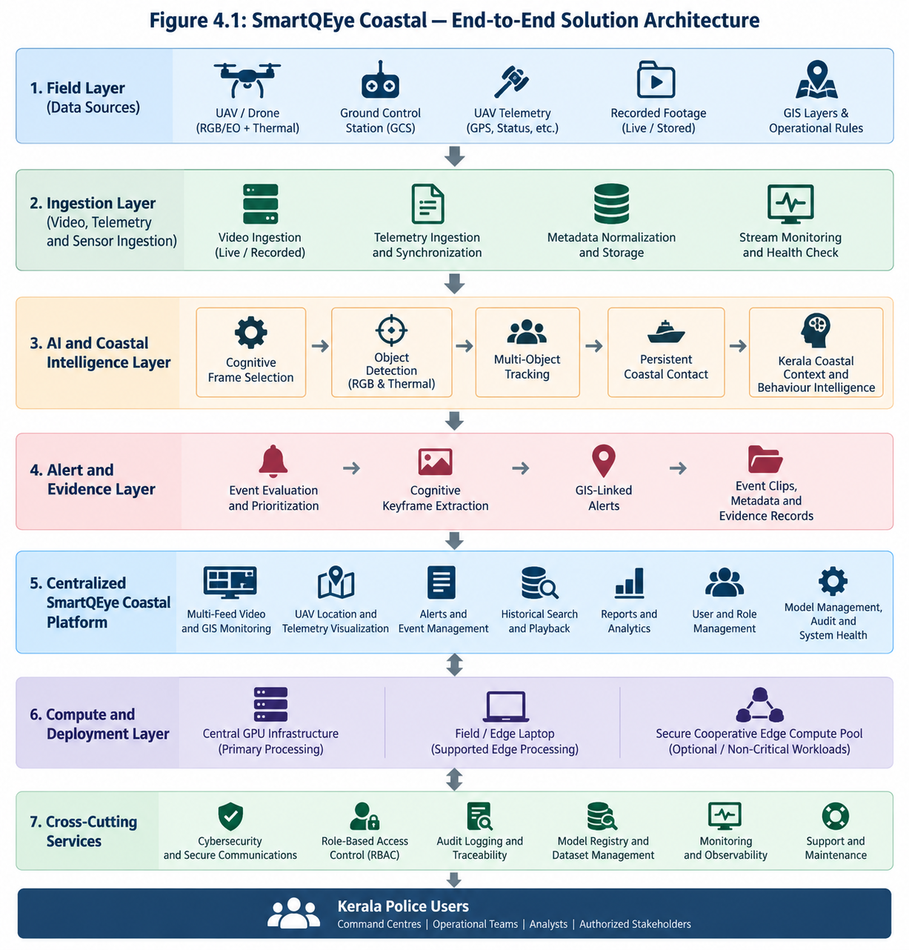
Figure 4.1 - SmartQEye Coastal End-to-End Solution Architecture
The Alert and Evidence Layer converts relevant analytical findings into operator-oriented information. Events are evaluated and prioritized according to configured operational rules and contextual information. Cognitive Keyframe Extraction identifies representative frames around important events, while GIS-linked alerts associate the event with available geographical information. Relevant video clips, images, metadata and contact history are then retained as structured evidence records for subsequent review.
The Centralized SmartQEye Coastal Platform provides the common operational interface for Kerala Police. It brings together multi-feed video and GIS monitoring, UAV location and telemetry visualization, alerts and event management, historical search and playback, reports and analytics, user and role management, model administration, audit information and system-health monitoring. Irrespective of where an individual AI workload is processed, the relevant operational outputs remain accessible through this centralized platform.
The architecture also separates the centralized operational platform from the underlying Compute and Deployment Layer. High-throughput processing can be performed using centralized GPU infrastructure, while approved field or edge laptops may perform selected local or post-mission analytics. An optional Secure Cooperative Edge Compute capability may additionally be used for suitable non-critical or batch workloads. These processing options do not replace the centralized platform; they provide flexibility in how computational workloads are executed.
Across all layers, cross-cutting services provide cybersecurity, secure communications, Role-Based Access Control, audit logging, traceability, model and dataset management, monitoring, observability and lifecycle support. The resulting architecture provides Kerala Police with a single centralized operational system while allowing the underlying analytics and compute infrastructure to evolve according to available UAV platforms, network conditions and processing resources.

6.3 Intelligence Processing and Coastal Analytics

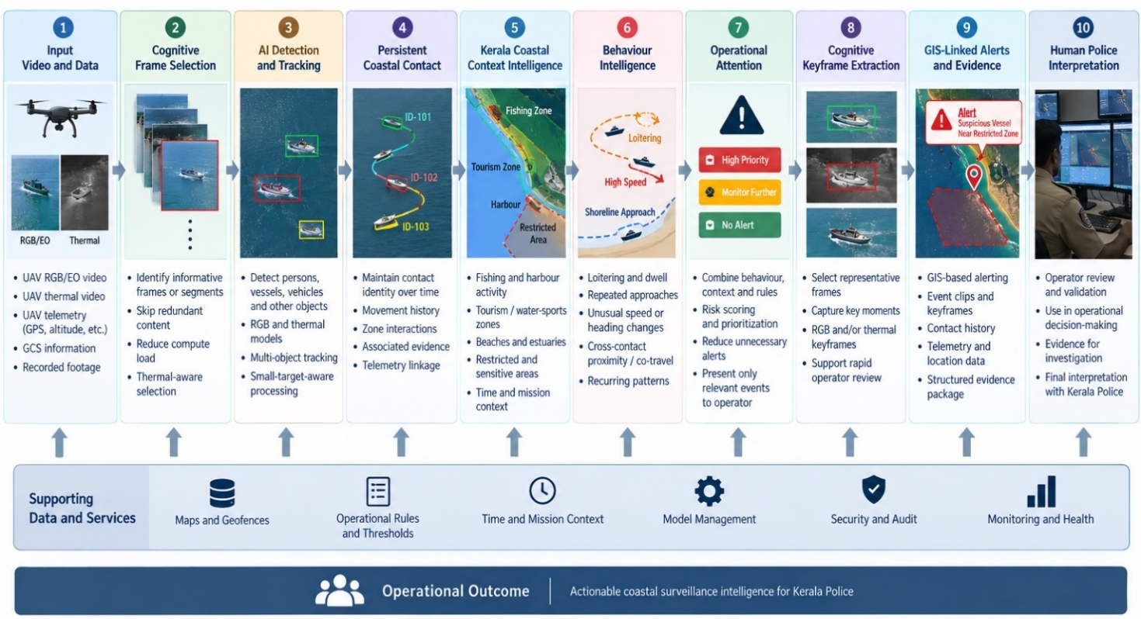
Figure 4.2 - Intelligence-processing Pipeline
The intelligence-processing pipeline shown in Figure 4.2 converts raw UAV video and telemetry into structured coastal-surveillance intelligence through a sequence of progressively higher-level analytical stages. The design intentionally separates basic perception from contextual interpretation so that detection, tracking, behaviour analysis and alert generation remain explainable and can be independently validated.
Processing begins with live or recorded RGB/EO and thermal video, together with available UAV telemetry, Ground Control Station information and mission metadata. Cognitive Frame Selection then identifies informative frames or short temporal segments for deeper processing, reducing unnecessary computation on repetitive video while retaining frames associated with movement, object appearance, track uncertainty or operationally relevant scene changes.
Selected imagery is processed through AI-based detection and multi-object tracking to identify persons, vehicles, boats, vessels and other configured objects. Small-target-aware processing will be applied where required for distant or low-resolution coastal objects. Tracking results are then consolidated into Persistent Coastal Contacts, allowing the platform to maintain observation history, movement, zone interactions, telemetry association and relevant evidence beyond individual frames or short-lived tracker IDs.
Higher-level analysis combines these persistent contacts with Kerala Coastal Context Intelligence. The same observed behaviour may have different significance depending on whether it occurs within a fishing area, harbour, tourism or water-sports zone, beach, estuary or restricted location. Time, mission context, configured geofences and operational rules can therefore be considered alongside the visual observations.
Temporal and cross-contact analytics subsequently examine patterns developing over time, including prolonged presence, repeated approaches, recurring zone entry, unusual movement changes, extended proximity between contacts and repeated interaction. These observations are used by the Context-Aware Operational Attention stage to determine whether activity should simply be retained, monitored further or presented to the operator with increased priority. This helps reduce unnecessary alert volume without discarding potentially useful observations.
For significant events, Cognitive Keyframe Extraction selects representative RGB and/or thermal frames that clearly summarize the event. These keyframes are combined with relevant video clips, contact history, telemetry and GIS information to create a structured alert and evidence package. The resulting information is presented through the centralized SmartQEye Coastal platform for review and interpretation by authorized Kerala Police personnel.
The pipeline is supported throughout by GIS layers and geofences, operational rules and thresholds, mission and temporal context, model-management controls, security and audit mechanisms, and continuous system-health monitoring. The final operational decision therefore remains with Kerala Police, while SmartQEye Coastal provides the underlying detection, continuity, context, behavioural evidence and prioritization required to support that decision.

6.4 GIS, Telemetry, Alerts, Evidence and Centralized Monitoring
SmartQEye Coastal integrates video analytics with available UAV telemetry and GIS information so that detected events are associated with their operational location and mission context. The platform will ingest available GPS position, altitude, heading, ground speed, flight status, drone identification and mission information and synchronize these with the corresponding video stream. Where suitable camera/gimbal orientation and calibration information is available, enhanced target or event geolocation may also be supported.
The centralized GIS interface will display UAV position, flight trajectory, surveillance areas, geofences and detected events. Kerala Police personnel will be able to define operational zones such as restricted areas, harbour regions, fishing zones, beaches, tourism locations and other areas requiring differentiated monitoring. Location, time, object type and configured operational conditions can then be used when evaluating events and generating alerts.
Alerts will be configurable according to event type, geographical zone, threshold, time condition, sensitivity, priority/severity and notification or escalation requirements. Each alert can include the event type, date and time, UAV identification, available coordinates, relevant contact information and associated visual evidence. Context-aware prioritization will help distinguish routine observations from events requiring immediate operator attention.
For significant events, SmartQEye Coastal will generate structured Evidence-Linked Incident Records containing relevant video clips, Cognitive Keyframes, AI overlays, contact history, available telemetry, GIS context and alert information. Operator review and subsequent authorized actions will also be recorded, providing a traceable event history for later examination and reporting.
The centralized monitoring dashboard will bring together live multi-feed video, GIS visualization, UAV telemetry, AI overlays, alerts, event history, recorded-video playback, historical search, reports, user and role management and system-health information. Operators will therefore be able to move from a live alert to the associated map location, video evidence and contact history within the same operational environment.
Historical search and playback will allow authorized personnel to retrieve events using parameters such as date/time, UAV, mission, event type, surveillance zone and other available metadata. Irrespective of whether individual AI workloads are processed centrally or on an authorized edge system, relevant alerts, evidence, contact information and operational status will remain available through the centralized SmartQEye Coastal platform.

6.5 AI Model, Dataset and Technology Strategy
SmartQEye Coastal will use a modular and model-independent AI architecture so that detection, tracking and higher-level analytics components can be upgraded without redesigning the complete platform. For production deployment, preference will be given to technically suitable components with permissive open-source licences and clear provenance, reducing unnecessary recurring licensing dependencies and long-term vendor lock-in.
For object detection, the initial production candidates will include RTMDet/MMDetection and RT-DETR, with ByteTrack or equivalent detector-independent tracking for multi-object continuity. Final model selection will be based on validation using representative coastal footage, with particular emphasis on small-object performance, inference speed, tracking stability, false detections and GPU-resource requirements. Different model profiles may be used for centralized GPU servers and resource-constrained edge systems while maintaining a common object taxonomy and event schema.
RGB/EO and thermal imagery will initially use separate sensor-specific models. This avoids assuming identical resolution, field of view, frame rate or pixel alignment between the two modalities. Their outputs will be correlated using timestamps, telemetry, tracking and Persistent Coastal Contact information. More advanced cross-modal fusion may be introduced after evaluation of the actual UAV payload and availability of suitably synchronized RGB/thermal data.
Model adaptation will follow a staged dataset strategy. Public or appropriately licensed datasets may be used for initial engineering and baseline development, followed by authorized Kerala Police coastal footage for local adaptation. The Kerala-specific dataset will progressively cover variations in vessel type, target size, UAV altitude, viewing angle, illumination, sea conditions, glare, harbour and beach environments, tourism activity and thermal/night imagery. Difficult examples and recurring false detections identified during validation will be incorporated through controlled dataset improvement.
Each operational model will be managed through a controlled lifecycle covering dataset version, model version, class taxonomy, training configuration, validation results, deployment profile and approval status. Candidate models will be evaluated before operational deployment, and previous validated versions will be retained to support rollback where required. Operator feedback may contribute to subsequent dataset refinement, but deployed models will not be modified through uncontrolled or automatic retraining.
A representative technology stack is proposed below:
Layer | Proposed Technologies / Approach
Frontend / Web Dashboard | React.js + TypeScript
GIS / Map Visualization | MapLibre GL / OpenLayers / Leaflet, subject to final GIS requirements
AI Detection | RTMDet / MMDetection, RT-DETR or validated equivalent
Multi-Object Tracking | ByteTrack or equivalent
Training Framework | PyTorch
Optimized Inference | ONNX Runtime / TensorRT, where applicable
Video Processing / Streaming | OpenCV, FFmpeg, GStreamer
Backend / APIs | Python, FastAPI
Operational Database | PostgreSQL
Geospatial Data and Queries | PostgreSQL + PostGIS
Evidence / Object Storage | S3-compatible object storage or Kerala Police-approved equivalent
Cache / Fast State | Redis or equivalent
Identity and Access Management | Keycloak or integration with Kerala Police identity infrastructure
Monitoring / Observability | Prometheus, Grafana and centralized logging
Deployment | Docker/containerized services on centralized and approved edge infrastructure
API / Integration | REST APIs and modular adapters for UAV/GCS, telemetry, GIS and authorized Police systems
The final technology selection will remain subject to performance validation, cybersecurity requirements, target deployment infrastructure and Kerala Police approval. The core value of SmartQEye Coastal does not depend on any single detector or software framework; it lies in the integrated coastal dataset, model adaptation, Cognitive Frame Selection, Persistent Coastal Contact Intelligence, contextual and behavioural analytics, evidence management and controlled model lifecycle. All production AI components will therefore be accompanied by documented model provenance, software provenance and applicable licence information. Any detector or software component requiring a commercial, restrictive or otherwise specifically governed production licence will be introduced only after explicit approval of the associated licensing arrangement.

6.6 Deployment and Compute Architecture
SmartQEye Coastal is designed around a centralized operational platform with flexible placement of compute resources. The centralized platform remains the common layer for monitoring, GIS, alerts, evidence, historical search, user management, audit and model governance, while the actual AI workload may be executed centrally, at the field edge or through other authorized processing resources depending on the available infrastructure and mission conditions.
The preferred deployment model uses the UAV and Ground Control Station at the field level, with a field/edge laptop acting as the acquisition and gateway node. Video and telemetry are forwarded to centralized ingestion and GPU-processing services, while alerts, evidence and operational information are presented through the centralized SmartQEye Coastal dashboard. This model provides the strongest support for multi-feed processing, centralized control, consistent model versions and evidence management.
SmartQEye Coastal will also support local edge processing where the available laptop GPU can perform selected analytics directly at the field or police-station level. This mode can reduce dependence on continuous high-bandwidth connectivity and can support post-mission analysis. However, the processing capability will depend on the actual laptop hardware, number of streams, resolution and selected models. Relevant alerts, metadata and evidence generated locally will therefore be synchronized with the centralized platform when connectivity is available.
A third option is Secure Cooperative Edge Processing, in which approved GPU-enabled laptops may contribute spare compute capacity for suitable batch, post-mission or overflow workloads. This model is treated as an optional resource-sharing mechanism rather than a dependency for mission-critical real-time surveillance, since network latency, node availability and secure workload distribution can affect predictability.
The architecture will also remain compatible with a future or enhanced UAV-onboard edge-processing model where the selected drone supports an integrated edge-AI device and/or suitable 4G/5G communication. In such a configuration, selected inference or pre-processing can be performed closer to the sensor before transmitting results or video to the centralized platform. Its use will depend on UAV payload interfaces, available onboard compute, power and thermal limits, communication capability and network coverage.
These deployment models provide Kerala Police with operational flexibility without creating separate versions of the system. All configurations use the same SmartQEye Coastal intelligence pipeline, event schema, model-governance framework and centralized operational platform, allowing deployment to be selected according to infrastructure, connectivity and mission requirements.

6.6.1 Centralized GPU Processing with Field/GCS Gateway
The architecture shown in the figure represents the preferred deployment model for SmartQEye Coastal, with field acquisition separated from centralized high-performance processing and operational monitoring. The UAV and Ground Control Station remain close to the mission, while computationally intensive AI workloads, evidence management and centralized supervision are handled within the backend infrastructure. This arrangement provides a practical balance between field flexibility, centralized control, scalable GPU processing and consistent evidence management.
At the field level, the UAV carries the RGB/EO and thermal sensors required for daytime, night-time and reduced-visibility surveillance. Video and available telemetry are received through the Ground Control Station and field laptop. The field system acts primarily as the mission interface and gateway, supporting video reception, telemetry capture, local preview and operator interaction rather than carrying the full central AI workload.
Video, telemetry and associated metadata are transmitted through a secure communication path to the centralized backend. Depending on the available operational infrastructure, this connection may use an approved wired, wireless, 4G/5G or other authorized communication mechanism. The architecture does not depend on a specific communication technology; the important requirement is reliable and secure transport of the required video, telemetry and metadata.
Within the central backend, the ingestion server receives the incoming streams, handles the relevant protocols, normalizes metadata and maintains synchronization between video and telemetry. Separating ingestion from AI inference prevents communication and stream-handling functions from being tightly coupled to the analytical models and makes it easier to integrate additional UAV platforms in the future.
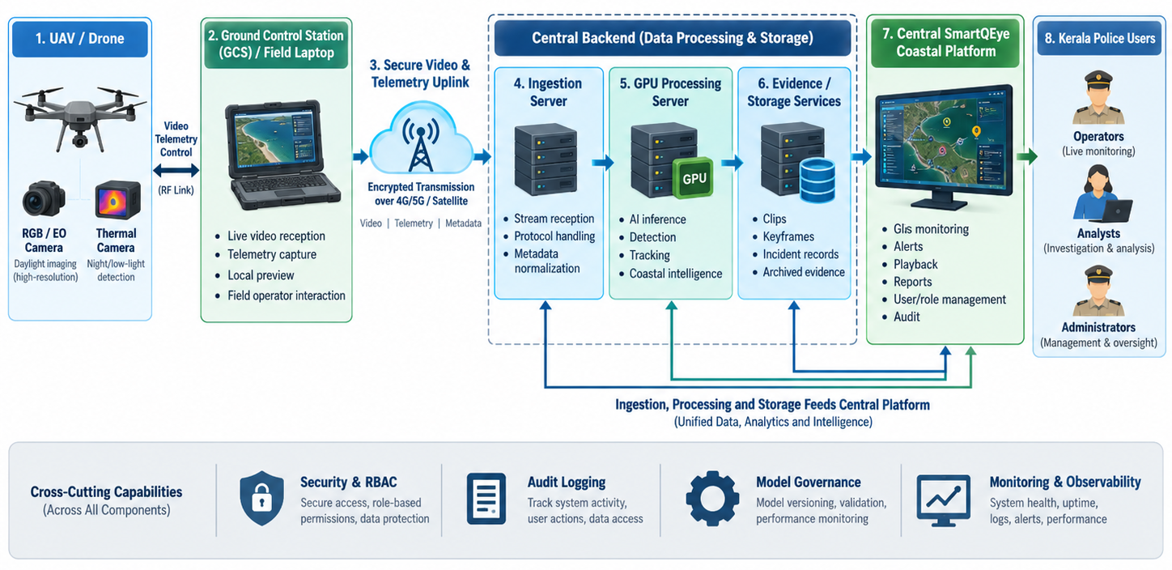
Figure 4.3 - Centralized GPU Processing with Field/GCS Gateway
The normalized streams are then forwarded to the central GPU-processing server, where SmartQEye Coastal performs Cognitive Frame Selection, object detection, multi-object tracking, Persistent Coastal Contact management and contextual and behavioural analytics. Centralized GPU processing provides the strongest operating environment for high-resolution inference, simultaneous multi-feed analysis and deployment of more computationally demanding models. It also allows model versions and processing configurations to be controlled consistently across all connected UAV feeds.
A separate evidence and storage service maintains event clips, Cognitive Keyframes, incident records, analytical metadata and other authorized evidence. Keeping evidence management logically separate from the inference server improves maintainability and allows storage, retention and backup policies to be managed independently from AI processing capacity.
The central SmartQEye Coastal platform combines the outputs of ingestion, analytics and evidence services into a unified operational interface. Authorized personnel can monitor live feeds, view UAV locations and GIS information, receive and review alerts, search historical events, replay recorded evidence, generate reports and manage users, roles and audit information. This centralized platform remains the common operational layer even if additional edge-processing options are introduced later.
The architecture also incorporates cross-cutting controls for security and RBAC, audit logging, model governance, monitoring and observability. These controls apply across ingestion, GPU processing, evidence storage and the centralized dashboard so that access, model versions, system activity and operational health remain traceable.
The main advantage of this deployment model is that it keeps the field setup relatively simple while concentrating compute-intensive workloads in infrastructure that can be sized and upgraded centrally. It is therefore the most suitable configuration for the full multi-feed SmartQEye Coastal deployment, particularly where reliable connectivity is available between the GCS/field gateway and the central processing environment. Its principal dependency is the availability of sufficient network bandwidth and connectivity for live video transmission; where this is constrained, the local edge-processing model described in the next subsection provides an alternative operating mode.

6.6.2 Local Edge Processing with Central Synchronization

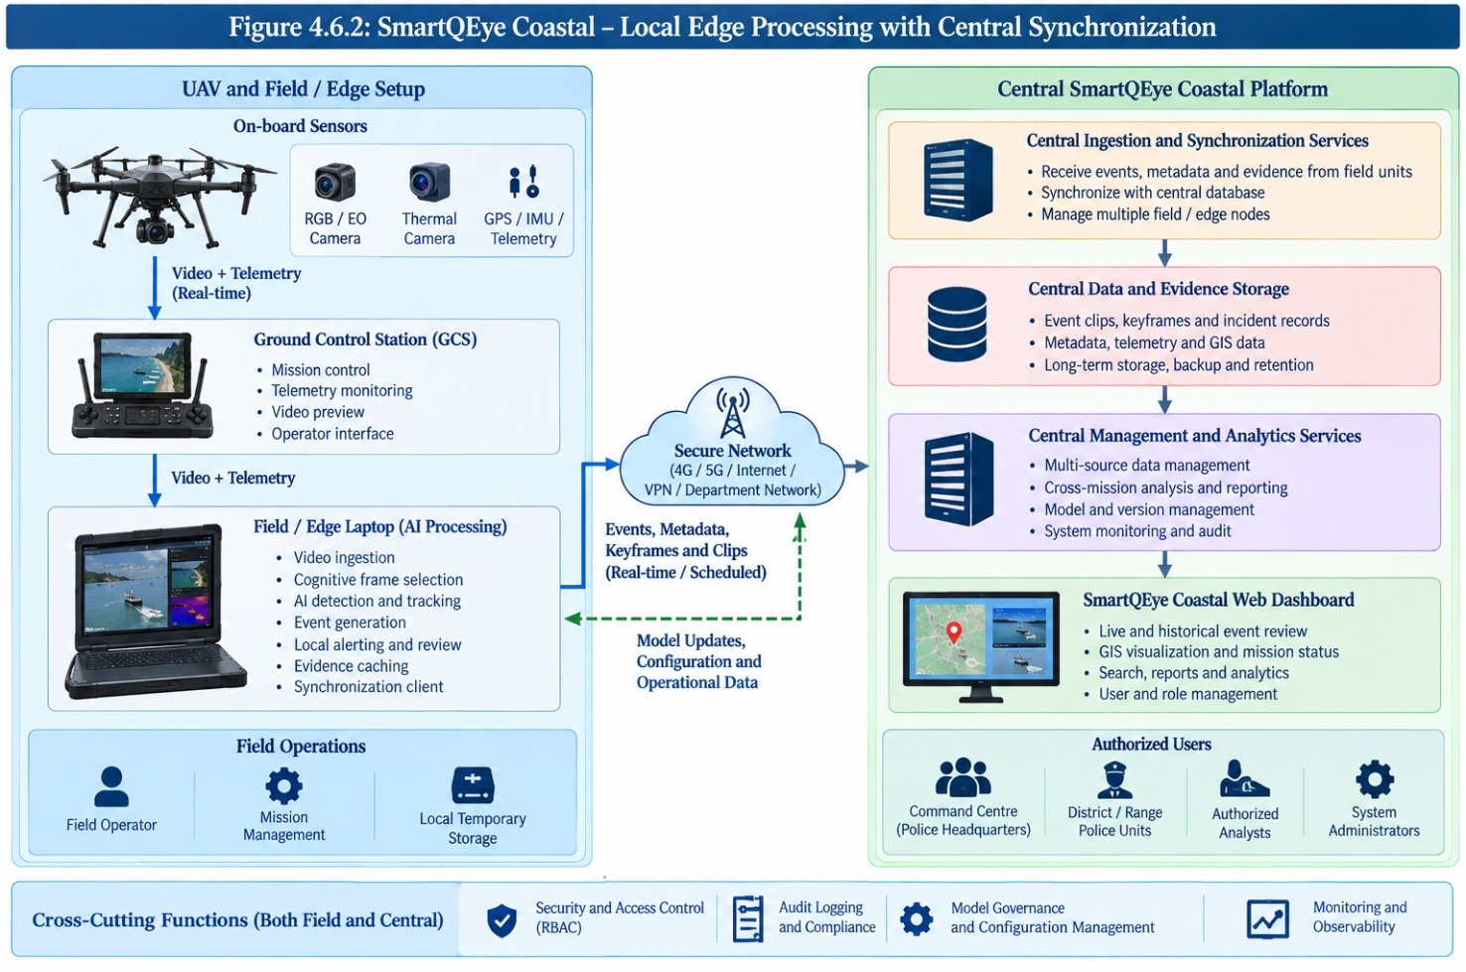
Figure 4.4 - Local Edge Processing with Central Synchronization
The architecture shown in Figure 4.6.2 represents a deployment mode in which the field or edge laptop performs the primary AI processing close to the UAV mission, while the centralized SmartQEye Coastal platform receives synchronized events, metadata, evidence and operational information. This model is particularly useful when continuous high-bandwidth transmission of full-resolution video to the central infrastructure is difficult or unnecessary, while still preserving centralized monitoring, evidence management and governance.
At the field level, the UAV provides RGB/EO and thermal video together with available GPS, IMU and other telemetry. The Ground Control Station supports mission control, telemetry monitoring and local video preview. The field/edge laptop then receives the video and telemetry streams and performs the selected SmartQEye Coastal processing pipeline locally, including video ingestion, Cognitive Frame Selection, AI detection, multi-object tracking, event generation and local operator review.
Because processing takes place on the edge laptop, the system does not need to continuously transmit every raw video frame to the central platform. Instead, the field node can upload events, metadata, Cognitive Keyframes, selected clips and other evidence, either in near real time or through scheduled synchronization depending on connectivity and operational policy. This can significantly reduce bandwidth requirements, especially during prolonged missions.
The local edge node can also maintain temporary evidence and processing state when network connectivity is weak or unavailable. Once communication is restored, the synchronization client can forward the queued events and evidence to the central platform. This provides a degree of operational resilience while still ensuring that important information ultimately becomes available through the centralized SmartQEye Coastal system.
At the central side, the ingestion and synchronization services receive information from one or more field nodes and reconcile it with the central database and evidence repository. The central storage layer preserves event clips, keyframes, incident records, telemetry, GIS information and other relevant metadata according to configured retention and backup policies.
The central management and analytics services provide cross-mission data management, historical analysis, reporting, model/version management, system monitoring and audit. This allows Kerala Police to maintain a unified operational picture even though the original AI inference may have taken place at different field locations.
The centralized web dashboard continues to provide GIS visualization, event review, historical search, reports, analytics, user management and role-based access. The central system can also send validated model updates, configuration changes and operational parameters back to authorized edge laptops, allowing the field systems to remain aligned with centrally approved models and rules.
The principal advantage of this deployment model is reduced dependence on continuous high-bandwidth connectivity. It also allows useful operation in areas where network quality varies and supports post-mission processing on the field laptop. However, its practical capability depends on the actual GPU, memory, thermal capacity and processing load of the edge laptop. A laptop with limited GPU resources may support selected analytics effectively, but may not sustain the same number of high-resolution RGB and thermal streams or the same model complexity as centralized GPU infrastructure.
For this reason, Local Edge Processing should be treated as a supported operational mode rather than the primary architecture for the full twenty-feed centralized requirement. It is particularly suitable for single-drone or limited-stream missions, degraded-connectivity conditions, local review and post-mission analysis. Central synchronization ensures that the overall SmartQEye Coastal system still maintains unified evidence, GIS information, auditability, reporting and model governance across all field deployments.

6.6.3 Cooperative Edge Processing
The Cooperative Edge Processing model extends SmartQEye Coastal beyond a single field laptop by allowing multiple authorized edge systems to contribute available compute resources to selected workloads. As shown in the figure, each field or police-unit node can continue to perform its own local video ingestion and selected AI processing, while spare GPU capacity may be coordinated through a secure distributed processing layer. The centralized SmartQEye Coastal platform remains the authoritative system for events, evidence, historical data, user management, model governance and audit.
Each participating edge node may operate independently for its primary mission while also exposing limited, authorized compute capacity to the cooperative pool. A coordination layer manages job queues, node availability, workload assignment and processing status. Suitable workloads may include post-mission video analysis, queued recorded footage, secondary inference, model evaluation, dataset preprocessing or other non-time-critical tasks.
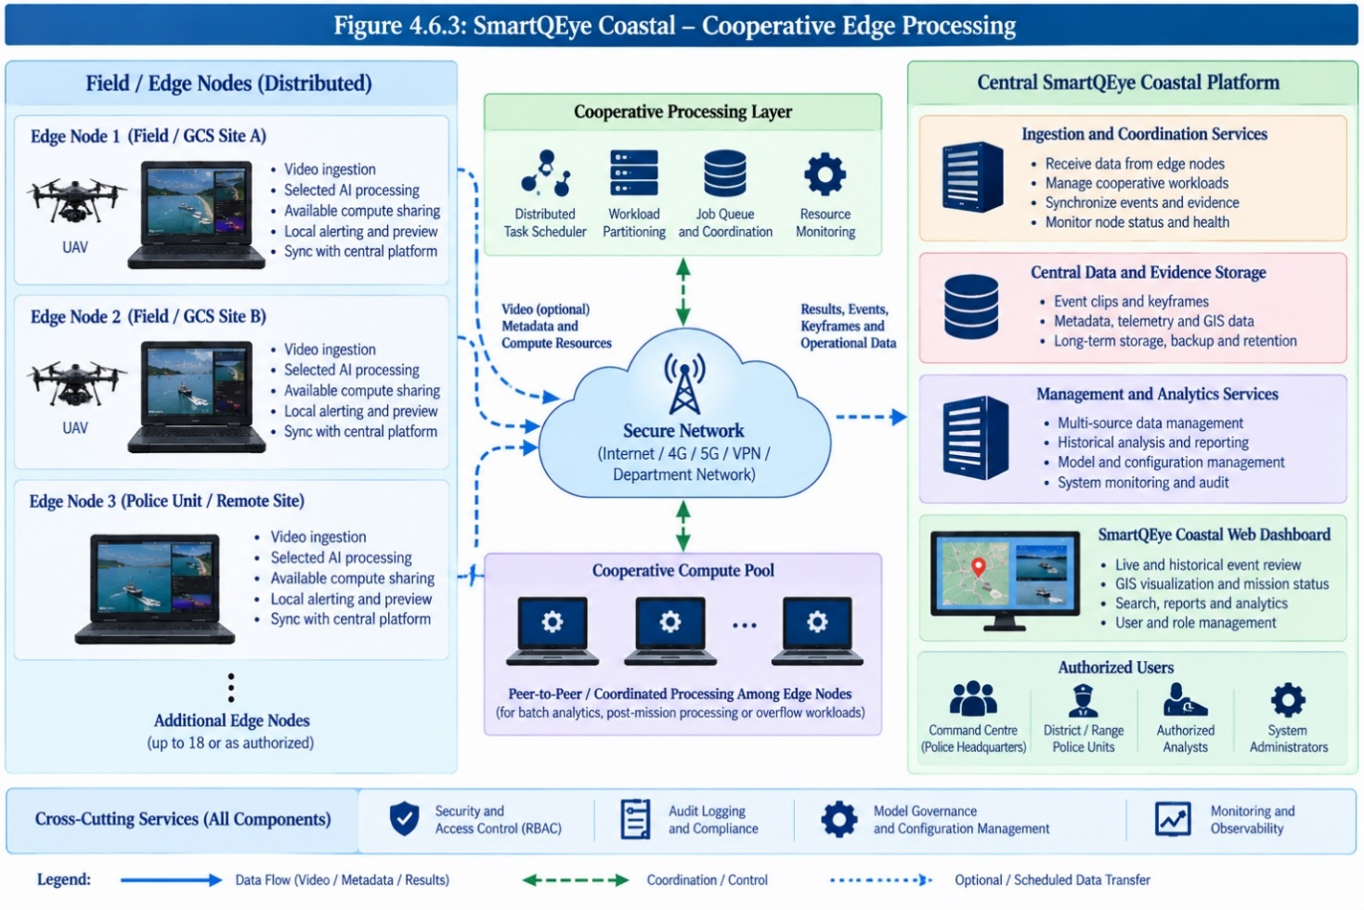
Figure 4.5 - Cooperative Edge Processing
The architecture does not require continuous transfer of all raw video among participating laptops. Wherever possible, workload distribution can use selected clips, frames, metadata or other restricted processing inputs according to the approved data-locality and security policy. Results, events, keyframes and associated metadata are returned to the central platform after processing.
The centralized system coordinates the distributed nodes, receives their outputs and maintains synchronized event and evidence records. It also provides common model versions, configuration parameters, operational rules and access-control policies so that processing carried out at different edge locations remains consistent with the centrally governed SmartQEye Coastal environment.
A major advantage of this model is the ability to utilize otherwise idle GPU resources distributed across police units without requiring every workload to be executed on the main central server. It may therefore provide additional capacity for batch or post-mission analysis and can improve overall infrastructure utilization where multiple GPU-enabled laptops are available.
However, this model has practical limitations. Network quality, different laptop configurations, node availability, cybersecurity requirements, workload-transfer overhead and synchronization can make distributed real-time inference less predictable than processing on a dedicated central GPU server. For this reason, SmartQEye Coastal will not depend on Cooperative Edge Processing for primary mission-critical real-time surveillance.
The proposed role of this deployment mode is therefore as an optional supplementary compute capability for authorized non-critical, batch, overflow and post-mission workloads. Centralized GPU processing and local field processing remain the principal operational modes, while Cooperative Edge Processing can be enabled where Kerala Police infrastructure and network conditions make its use beneficial.

6.6.4 UAV-Onboard Edge Processing and Cellular Connectivity

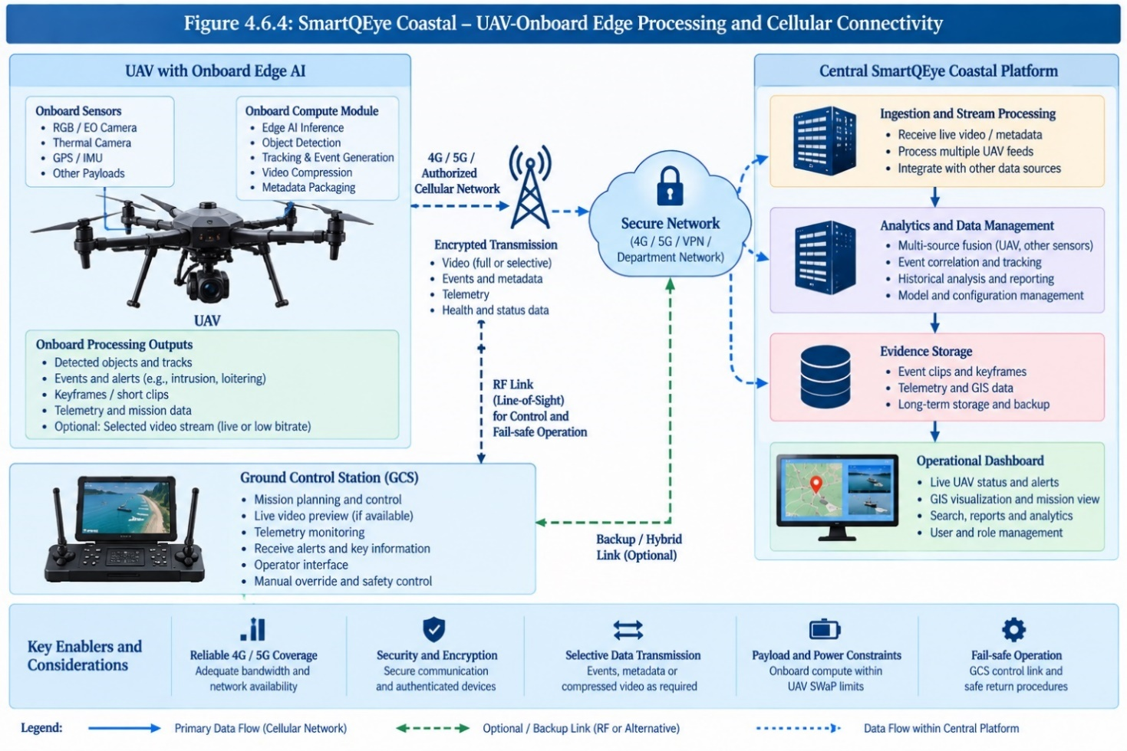
Figure 4.6 - UAV-Onboard Edge Processing and Cellular Connectivity
The architecture shown in Figure 4.6.4 represents an enhanced deployment model in which part of the SmartQEye Coastal analytics pipeline is moved directly onto the UAV through an onboard edge-compute module. In this arrangement, RGB/EO and thermal video, together with GPS/IMU and other available telemetry, can be processed close to the sensor before information is transmitted to the Ground Control Station or centralized SmartQEye Coastal platform.
The onboard compute module may perform selected functions such as object detection, tracking, event generation, video compression and metadata packaging. Instead of transmitting the complete raw video stream continuously, the UAV may transmit selected video, event metadata, keyframes, alerts and telemetry depending on mission requirements, available bandwidth and the capabilities of the selected UAV platform. This can reduce communication load and allow useful analytical results to be generated with lower dependence on a high-bandwidth backhaul connection.
Where the UAV supports suitable 4G/5G or other authorized cellular connectivity, analytical results and selected video can be transmitted securely to the centralized SmartQEye Coastal platform. The central system continues to provide ingestion, cross-mission analytics, event correlation, evidence storage, historical analysis, reporting, user management and GIS-based operational monitoring. The overall system therefore remains centralized even though part of the AI processing is performed onboard.
The Ground Control Station remains an important component of this model. It continues to support mission planning and control, telemetry monitoring, operator interaction and available video preview. The normal UAV control link should remain logically separate from the SmartQEye Coastal analytics path so that surveillance analytics do not become a dependency for basic flight safety or mission control. Where supported by the selected UAV architecture, the GCS may also receive onboard-generated alerts and selected analytical information.
A major advantage of this model is that processing occurs close to the sensor. This can reduce the quantity of data transmitted to central infrastructure, improve responsiveness for selected events and enable useful surveillance functions even when the backhaul bandwidth is constrained. It can also allow the central platform to receive structured events and evidence rather than continuously processing every frame from every UAV.
However, this model is strongly dependent on the capabilities of the actual UAV platform. Onboard implementation must consider available compute capacity, GPU/accelerator support, payload interfaces, power consumption, additional weight, thermal constraints, software-development interfaces and access to the RGB/thermal video streams. Cellular connectivity will also depend on the availability and quality of the communication network within the actual operating area.
For these reasons, UAV-Onboard Edge Processing and Cellular Connectivity is proposed as an architecture-supported enhanced deployment option rather than a mandatory baseline configuration. It can be adopted where the designated UAV platform provides appropriate onboard compute and communication capabilities. The primary SmartQEye Coastal architecture will remain capable of operating through the GCS/field gateway and centralized or local edge-processing models even when onboard AI or cellular connectivity is unavailable.

6.6.5 Comparative Assessment and Recommended Deployment Strategy
The four deployment models differ primarily in where AI processing is performed, while the centralized SmartQEye Coastal operational platform remains common to all models. The centralized platform provides GIS visualization, alerts, evidence management, historical search, reporting, user and role management, audit, model governance and system monitoring. A central GPU server is required only where AI inference is intended to be performed centrally.
For the proposed Kerala Police implementation, the two immediately practical models are Centralized GPU Processing with Field/GCS Gateway and Local Edge Processing with Central Synchronization.
In the Centralized GPU Processing model, the field/GCS environment acquires video and telemetry and forwards the required streams to centralized GPU infrastructure. The central GPU executes the main analytics pipeline, including detection, tracking, Persistent Coastal Contact processing and higher-level contextual and behavioural analytics. This configuration provides the greatest compute capacity and is the preferred model for large-scale, multi-feed and computationally intensive operation. Its principal dependencies are availability of centralized GPU resources and sufficient connectivity between the field location and the processing infrastructure.
In the Local Edge Processing model, AI inference is performed on the field laptop itself and a central GPU server is not required. The laptop executes the analytics profile validated for its available hardware, which may include Cognitive Frame Selection, detection, tracking, Persistent Coastal Contact processing, behaviour analytics, event generation, Cognitive Keyframe Extraction and local evidence preparation. Alerts and analytical results are immediately available to the field operator, subject to the processing capability of the laptop. The locally generated contact metadata, telemetry, keyframes, selected clips and evidence are synchronized with the centralized SmartQEye Coastal platform. Depending on network conditions, synchronization may occur in real time, near real time or after connectivity is restored. Consequently, local analytics can continue during a network interruption, although the centralized operational picture may temporarily lag behind the field system.
The capability of the Local Edge Processing model will depend on the laptop GPU, available VRAM, video resolution, number of RGB/thermal streams and selected model profile. Cognitive Frame Selection, optimized inference and lighter model variants may therefore be used where required. The actual real-time operating envelope will be established through benchmarking on the available Kerala Police field hardware. More computationally intensive processing can also be performed in post-mission mode where real-time latency is not required.
The two models may be used within the same overall SmartQEye Coastal deployment, but they do not require automatic migration of workloads between central and edge systems. Each mission or UAV feed can be assigned an appropriate processing mode according to available compute resources, connectivity and operational requirements.
Deployment Model | Where AI Processing Occurs | Central GPU Required? | Key Advantage | Principal Constraint | Proposed Role
Centralized GPU Processing with Field/GCS Gateway | Central GPU infrastructure | Yes | Highest processing capacity and easier multi-feed scaling | Requires central GPU resources and adequate field-to-central bandwidth | Preferred for full-scale and multi-feed operation
Local Edge Processing with Central Synchronization | Field/edge laptop | No | Field autonomy and reduced continuous video uplink | Limited by laptop GPU and number/resolution of streams; central synchronization may be delayed | Independent mode for single/limited-feed, bandwidth-constrained and post-mission operation
Cooperative Edge Processing | Multiple authorized edge laptops | No dedicated central GPU for distributed jobs | Utilizes otherwise idle GPU resources | Network, scheduling, security and node-availability complexity | Optional for batch, overflow and post-mission workloads
UAV-Onboard Edge Processing with Cellular Connectivity | UAV-mounted edge device | No for onboard analytics | Processing close to the sensor and reduced uplink requirement | Depends on compatible UAV hardware, power/thermal limits, interfaces and connectivity | Future / UAV-dependent enhancement
Cooperative Edge Processing will remain an optional supplementary capability. It may be used for recorded-video analysis, queued processing, dataset preparation or other non-critical workloads where spare GPU resources are available. Primary real-time surveillance will not depend on the availability of cooperative processing nodes.
UAV-Onboard Edge Processing will similarly remain a future or UAV-dependent option. SmartQEye Coastal does not assume the presence of onboard AI-compute hardware on the UAVs made available for the present project. Where future platforms provide suitable onboard compute, payload interfaces and communication capabilities, selected analytics can be moved closer to the sensor without changing the centralized operational architecture.
Accordingly, the recommended deployment strategy is:
- Full-scale and multi-feed operation: Centralized GPU Processing with Field/GCS Gateway.
- Single/limited-feed, bandwidth-constrained or post-mission operation: Local Edge Processing with Central Synchronization.
- Additional non-critical processing capacity: Cooperative Edge Processing, where practical.
- Future compatible UAV platforms: UAV-Onboard Edge Processing and Cellular Connectivity.
The key architectural distinction is therefore simple: AI processing may occur centrally or at the edge, but operational information is managed centrally. This provides flexibility in compute deployment while preserving a common SmartQEye Coastal dashboard, GIS environment, evidence repository, audit trail and model-governance framework.

6.7 API, Security and System Governance
SmartQEye Coastal will provide a secure and modular integration layer so that the platform can interface with compatible UAV/GCS systems, telemetry sources, GIS services and authorized Kerala Police applications without tightly coupling the core analytics engine to a particular vendor or platform. RESTful APIs and configurable adapters will be used for exchanging video-related metadata, telemetry, alerts, events, GIS information and other authorized operational data.
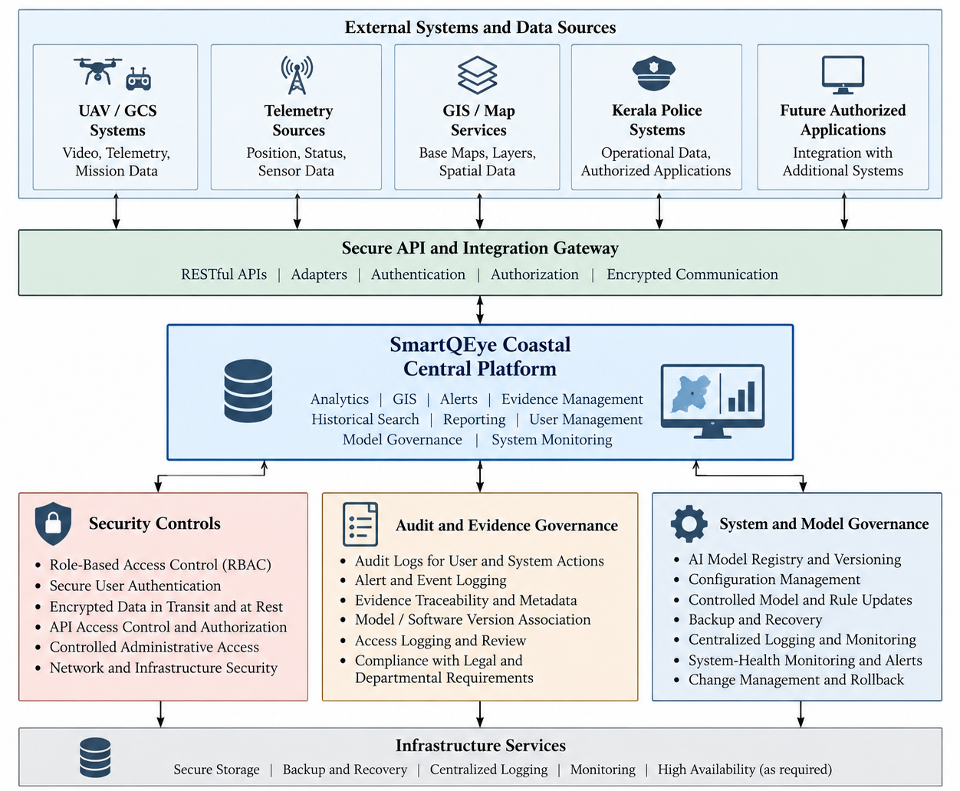
Figure 4.7 - SmartQEye Coastal API, Security and Governance Architecture
The API layer will support secure authentication and authorization, with access restricted according to assigned roles and permitted functions. Integration interfaces will be designed so that additional UAV platforms, external applications or future surveillance systems can be incorporated without major changes to the core SmartQEye Coastal architecture.
Security controls will be applied across the complete system, including field nodes, centralized services, databases, evidence storage and APIs. The platform will support Role-Based Access Control (RBAC), secure user authentication, controlled administrative access, encrypted communications, secure storage and configurable permissions for viewing, analysis, export, evidence access and system administration.
All significant user and system actions will be auditable. Alerts, operator actions, administrative changes, evidence access and relevant system events will be recorded to support traceability and subsequent review. Evidence-linked incident records will retain associated metadata, contact information, telemetry, GIS context and applicable model/software version information wherever required.
System governance will also include controlled management of AI models, configuration files, operational rules and deployment versions. Model or configuration updates will be introduced through authorized processes, with version tracking and rollback capability where applicable. Kerala Police data used for training or model refinement will remain subject to Department authorization and approved handling procedures.
Backup and recovery mechanisms will be provided for relevant databases, configuration, analytical metadata and evidence records according to the final deployment environment and Kerala Police retention requirements. System-health monitoring and centralized logging will support operational visibility, fault diagnosis and maintenance.
The solution will be implemented in accordance with applicable Government of India cybersecurity, data-protection, lawful-surveillance and digital-information handling requirements, together with Kerala Police-specific security and operational policies.

6.8 Development Environment and Production Transition
SmartQEye Coastal will follow a staged development and production-transition approach so that software development, model adaptation and system integration can begin without waiting for the final production infrastructure to be fully provisioned. The same application architecture and deployment packages will be used throughout the project so that the development environment can be transferred to the final Kerala Police infrastructure with minimal change.
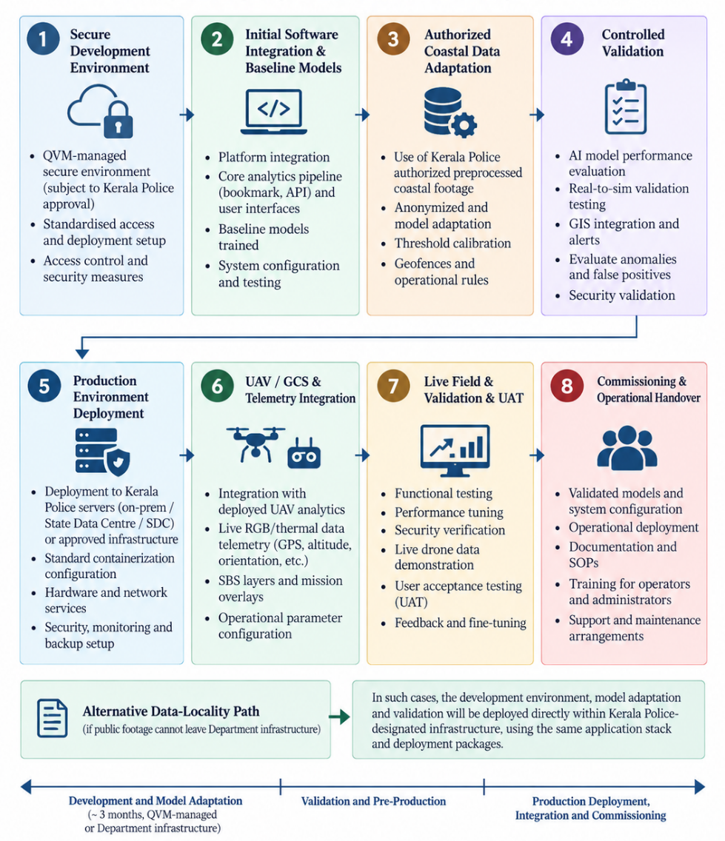
Figure 4.8 - SmartQEye Coastal Development-to-Production Transition
During the initial development and integration phase, expected to be approximately three months, the platform may be hosted in a secure QWI-managed environment, subject to Kerala Police approval and applicable data-security requirements. This environment will be used for software integration, AI-model development, dashboard development, workflow validation and adaptation using authorized pre-recorded coastal drone footage.
Where Kerala Police operational footage is not permitted to leave Department-controlled infrastructure, the same development stack can instead be deployed directly within infrastructure designated by Kerala Police. The proposed approach therefore does not depend on external cloud hosting and can accommodate Department-specific data-locality and security requirements.
Following initial development and validation, the system will be deployed or migrated to the final Kerala Police-designated production environment, which may include Department servers, Data Centre/State Data Centre infrastructure or another approved hosting environment. Production deployment will include the centralized SmartQEye Coastal platform, required databases and evidence services, security controls, monitoring components and the selected AI-processing configuration.
The platform will then be integrated with the designated UAV, Ground Control Station, RGB/thermal video feeds and available telemetry interfaces. Kerala-specific models, thresholds, geofences and operational rules will be refined using authorized field data and validation results.
The final transition will include functional testing, performance testing, security verification, live drone-feed analytics demonstration, user acceptance testing and commissioning. Validated models, system configurations, documentation and operational procedures will be transferred to the production environment under controlled version management. This staged approach enables early development and model adaptation while ensuring that the final operational system remains under Kerala Police-approved infrastructure, security, access-control and data-governance arrangements.

7. IMPLEMENTATION STRATEGY
The implementation of SmartQEye Coastal will follow a phased, validation-driven approach that progresses from platform preparation and baseline AI integration to Kerala-specific model adaptation, UAV/GCS integration, field validation, production deployment and commissioning. The implementation strategy is designed to minimize dependency on any single hardware or hosting configuration while ensuring that the final system operates within Kerala Police-approved infrastructure and security controls.
Development activities will proceed in parallel across the core software platform, AI analytics, RGB/thermal processing, GIS and telemetry integration, dashboard, evidence management and security components. Representative pre-recorded coastal footage will be used during early development and model adaptation, subject to Kerala Police authorization. Live UAV integration and operational validation will follow once the designated drone, GCS, telemetry interfaces and production environment are available.
The implementation will retain the modular architecture described in Section 4. Centralized GPU processing will support full-scale and multi-feed operation, while validated local edge processing may be used for limited-feed, bandwidth-constrained or post-mission scenarios. The centralized SmartQEye Coastal platform will remain the common operational environment for GIS, alerts, evidence, historical analysis, reporting, access control and audit.
The project will progress through defined milestones with measurable outputs, followed by functional testing, performance testing, security verification, live-drone demonstration, user acceptance and commissioning. Training, documentation and the required support period will form part of the final operational transition.

7.1 TECHNICAL APPROACH
The technical approach will follow an incremental develop → adapt → integrate → validate → deploy methodology so that each major subsystem can be tested independently before complete end-to-end integration.
The first stage will establish the SmartQEye Coastal application stack, including video and telemetry ingestion, backend services, React-based centralized dashboard, GIS services, databases, evidence storage, authentication, logging and monitoring. Baseline RGB/EO and thermal analytics will be integrated using the modular AI architecture defined in the proposed solution.
AI development will then focus on Kerala coastal adaptation. Initial models will be evaluated against representative footage, followed by controlled annotation, fine-tuning and threshold calibration using authorized Kerala Police data. Particular attention will be given to small boats and vessels, persons, vehicles, thermal imagery and difficult coastal conditions such as glare, changing viewpoints, varying target sizes and busy harbour or tourism environments.
The analytics pipeline will be progressively integrated with Cognitive Frame Selection, multi-object tracking, Persistent Coastal Contact Intelligence, contextual and temporal behaviour analytics, Cognitive Keyframe Extraction and evidence generation. These capabilities will be validated as individual modules and subsequently as a complete processing pipeline to reduce integration risk.
In parallel, the platform will integrate available UAV telemetry, GIS information and configurable operational zones. Video, telemetry and mission information will be synchronized, enabling location-linked events, geofencing, trajectory visualization and contextual alert generation. UAV/GCS-specific interfaces will be implemented through modular adapters so that the core system remains independent of a particular drone vendor.
The centralized dashboard will then be integrated with live and historical video, GIS, telemetry, alerts, evidence, reports, user/role management and system-health information. Security controls including authentication, RBAC, encrypted communication, audit logging, evidence traceability and backup mechanisms will be incorporated throughout the implementation rather than added only at the final stage.
Deployment will follow the selected production configuration. Where centralized GPU infrastructure is available, the full multi-feed analytics pipeline will be deployed centrally. Where a field laptop is intended to perform local processing, an optimized edge profile will be benchmarked and validated on the actual hardware. The processing capacity, supported resolution and number of simultaneous streams will be determined through performance testing rather than assumed in advance.
Following deployment to Kerala Police-approved infrastructure, the system will be integrated with the designated UAV/GCS and available RGB/thermal and telemetry feeds. End-to-end testing will cover detection and tracking, telemetry synchronization, GIS visualization, alerts, evidence generation, historical playback, multi-feed operation, access control, APIs and system monitoring.
The final stage will consist of live field validation, performance and security verification, user acceptance testing and commissioning. Findings from field testing will be used for controlled refinement of models, thresholds and operational configurations before final handover.

7.2 DELIVERABLES / MILESTONES
The project will be executed through clearly defined milestones so that software development, AI adaptation, integration, validation and production deployment can be reviewed progressively. Each milestone will produce identifiable technical outputs and will be subject to review before progression to the next stage.
Milestone | Major Activities | Key Deliverables
M1 – Project Initiation and Environment Setup | Finalization of requirements, interfaces, deployment assumptions, security approach and development environment | Detailed implementation plan, finalized system architecture, development environment, initial configuration and interface specifications
M2 – Core Platform and Baseline Analytics | Development/integration of video ingestion, telemetry handling, backend services, dashboard, GIS, databases and baseline AI models | Working SmartQEye Coastal baseline platform with RGB/EO and initial thermal-processing capability
M3 – Kerala Coastal Dataset and Model Adaptation | Authorized data collection/ingestion, annotation, model fine-tuning, small-target optimization and threshold calibration | Kerala-adapted AI models, versioned datasets, validation results and updated object taxonomy
M4 – Coastal Intelligence and Evidence Analytics | Integration of Cognitive Frame Selection, multi-object tracking, Persistent Coastal Contact, context/behaviour analytics, Cognitive Keyframe Extraction and evidence workflows | Integrated coastal-intelligence pipeline with alert, contact-history and evidence-generation capability
M5 – GIS, Telemetry, API and Centralized Dashboard Integration | GIS/geofence configuration, telemetry synchronization, API integration, alert management, historical search, reporting, RBAC and audit | Centralized operational dashboard with GIS, telemetry, alerts, evidence, reports, user management and APIs
M6 – Deployment and Performance Validation | Deployment on selected central/edge infrastructure, performance profiling, multi-feed testing, security verification and system monitoring | Validated deployment configuration, performance report, system-health monitoring and security-test findings
M7 – UAV/GCS Integration and Live Field Validation | Integration with designated UAV/GCS, RGB/thermal feeds and telemetry; live mission testing and refinement | Live drone-feed analytics demonstration, field-validation report and refined operational configuration
M8 – UAT, Commissioning and Handover | User acceptance testing, documentation, training, final configuration and commissioning | Commissioned SmartQEye Coastal system, user/admin/API documentation, training completion, acceptance/commissioning report and support handover
The final delivered system will include the SmartQEye Coastal software platform, centralized web dashboard, AI analytics and tracking modules, GIS and telemetry integration, alert and evidence-management functions, APIs, model-management capability, required software licences where applicable, system documentation, user and administrator training materials, testing and commissioning records, and support and maintenance documentation for the minimum three-year support period.

7.3 KEY BENEFITS TO BE ACHIEVED
The proposed SmartQEye Coastal implementation is expected to provide Kerala Police with a single centralized coastal surveillance environment that integrates UAV video, thermal imagery, telemetry, GIS information, AI analytics, alerts and evidence. This will reduce dependence on manual review of long-duration drone footage and provide operators with a structured view of events requiring attention.
A major benefit will be the transition from isolated object detection to Persistent Coastal Contact Intelligence. Persons, vehicles and vessels can be followed over time with their movement history, zone interactions, behavioural observations and associated evidence, enabling better understanding of evolving activity rather than relying on individual frame-level detections.
The platform will provide Kerala-specific contextual analytics for fishing areas, harbours, beaches, tourism and water-sports locations, estuaries and restricted zones. Combining geographical context with temporal behaviour and configurable operational rules is expected to reduce unnecessary alerts caused by normal coastal activity and improve the relevance of information presented to operators.
Integration of RGB/EO and thermal imagery will strengthen surveillance capability across different lighting and environmental conditions. Thermal analytics will provide complementary observations during night-time and low-visible-light operations, while the modular architecture will allow further sensor-specific refinement as representative operational data becomes available.
The combination of Cognitive Frame Selection and resource-aware processing will improve utilization of available GPU resources and support scalable multi-feed operation. The proposed architecture also provides flexibility to use centralized GPU processing, local edge processing or other approved configurations according to connectivity, hardware availability and mission requirements.
SmartQEye Coastal will improve operational traceability and evidence management by associating alerts with video clips, Cognitive Keyframes, telemetry, GIS information, contact history and operator actions. Historical search and playback will allow authorized personnel to retrieve and examine earlier events without manually reviewing complete mission recordings.
The modular API architecture will support integration with compatible UAV/GCS platforms, GIS services and authorized Kerala Police systems while allowing future expansion to additional UAVs, analytical models and operational locations. The model-independent AI architecture and preference for deployment-friendly technologies will further reduce unnecessary long-term dependency on a single detector or software vendor.
Overall, the project is expected to provide Kerala Police with a scalable, auditable and extensible coastal drone-surveillance platform that combines centralized operational visibility with flexible AI processing, controlled model improvement and evidence-oriented workflows. The RFP specifically envisages centralized monitoring, scalable architecture, GIS/telemetry integration, model evolution and future expansion, which are incorporated into the proposed design.

7.4 PROJECT SCHEDULE
The proposed implementation period for SmartQEye Coastal is 16 weeks (approximately four months) from the date of project commencement/work order, subject to timely availability of the designated UAV/GCS interfaces, representative authorized coastal footage, telemetry specifications, access to the required field systems and Kerala Police-designated deployment infrastructure.

Period | Major Activities | Expected Output
Month 1 / Weeks 1–4 | Project initiation; finalization of interfaces and deployment assumptions; development environment; core platform setup; video ingestion; telemetry framework; centralized dashboard; baseline RGB/thermal analytics | SmartQEye Coastal baseline platform and initial analytics environment
Month 2 / Weeks 5–8 | Authorized coastal dataset preparation; model adaptation; small-target optimization; tracking; Persistent Coastal Contact; GIS/geofencing; telemetry synchronization; alert workflows | Kerala-adapted analytics and integrated contact/GIS framework
Month 3 / Weeks 9–12 | Context and behaviour analytics; Cognitive Frame Selection; Cognitive Keyframe Extraction; evidence management; APIs; RBAC/audit; multi-feed profiling; deployment and security validation | Integrated pre-production SmartQEye Coastal platform
Month 4 / Weeks 13–16 | Deployment to Kerala Police-approved infrastructure; designated UAV/GCS integration; live RGB/thermal and telemetry validation; performance/security testing; UAT; training; documentation; commissioning | Operational system, acceptance/commissioning report and handover
The schedule is structured so that software development, AI-model adaptation, GIS/telemetry integration and dashboard development proceed in parallel wherever possible. The first three months will primarily focus on development, integration and controlled validation, while the fourth month will concentrate on production deployment, live UAV integration, field validation, training, acceptance and commissioning.
Activities requiring access to Kerala Police UAVs, operational telemetry, field locations or representative footage will be coordinated with the Department so that such dependencies do not unnecessarily delay parallel software-development activities.
The RFP requires installation and configuration, designated drone integration, video and telemetry configuration, GIS setup, user privileges, AI configuration, dashboard deployment, functional and performance testing, applicable security testing, live-drone-feed demonstration, acceptance testing and commissioning. The proposed four-month schedule is structured to complete these activities before operational handover.
Following successful commissioning, the project will enter the minimum three-year comprehensive support and maintenance period, including software corrections, updates and patches, agreed AI-model improvements, troubleshooting, integration support, performance monitoring, security updates and remote/on-site technical assistance as required.

7.5 SUPPORT REQUIRED FROM KERALA POLICE
Successful implementation of SmartQEye Coastal will require timely technical and operational coordination with Kerala Police, particularly for UAV integration, local model adaptation, deployment and acceptance testing. Core software development can proceed independently; however, final integration and operational validation necessarily depend on access to the designated drone systems, telemetry interfaces, deployment environment and representative coastal surveillance data. The RFP itself requires integration with designated drone systems, configuration of video/telemetry and GIS services, live-feed demonstration and acceptance testing.

The principal support required from Kerala Police is summarized below.
Support Required | Purpose
Designated Nodal/Technical Team | Coordination of requirements, technical interfaces, approvals, demonstrations, testing and acceptance
UAV and GCS Information | Details of designated UAV platforms, Ground Control Stations, RGB/EO and thermal payloads, available SDK/API interfaces and supported video-streaming mechanisms
Telemetry Interface Details | Availability and format of GPS, altitude, heading, speed, drone ID, mission information and other available telemetry
Representative Coastal Drone Footage | Authorized RGB and, where available, thermal/night footage representing Kerala coastal conditions for model adaptation, testing and false-alert reduction
Operational Context Inputs | Identification of representative fishing areas, harbours, beaches, tourism/water-sports zones, restricted areas and relevant operational scenarios
GIS and Geofence Information | Approved GIS layers, operational boundaries, surveillance zones and geofences required for map-based monitoring and alert configuration
Field Laptop / Edge Hardware Access | Access to the intended field hardware for benchmarking and validation of the Local Edge Processing profile
Deployment Infrastructure | Designation or approval of the production environment, including Department server/Data Centre/SDC or other approved infrastructure, together with required network and storage access
Cybersecurity and Data-Handling Requirements | Department-specific security policies, access requirements, data-retention rules, network restrictions and deployment/security review procedures
Integration Access | Controlled access to authorized Police systems or interfaces that are required to be integrated through the SmartQEye Coastal API layer
Field Testing and UAV Availability | Availability of designated UAV/GCS systems, operators, suitable test locations and permissions for live-feed integration and field validation
UAT and Acceptance Team | Nomination of authorized personnel for functional evaluation, UAT, live demonstration and commissioning
Training Nominees | Nomination of operators, administrators and technical personnel for system training and handover
Timely Review and Approvals | Review of model/data use, operational configurations, security settings, deployment changes and milestone outputs
For AI-model adaptation, Kerala Police support will be particularly important because any training or modification using Police-provided datasets will be undertaken only with the authorization and supervision of the designated authority. Where available and operationally permissible, representative footage may cover variations in vessel size, UAV altitude and viewing angle, harbour and near-shore environments, fishing and tourism activity, and RGB/thermal operating conditions.
The designated UAV and GCS need not be continuously available throughout the four-month development period. Their availability will be particularly important during interface integration, field validation and final acceptance. Where operational footage cannot leave Kerala Police-controlled infrastructure, QWI can deploy the required development and model-adaptation environment within infrastructure approved by the Department.
Timely availability of the above inputs will support adherence to the proposed 16-week implementation schedule, particularly for Kerala-specific model adaptation, UAV/GCS integration, live-feed testing and commissioning. Final acceptance will be based on successful demonstration using compatible coastal-surveillance drone feeds and satisfactory completion of testing and commissioning by the designated Kerala Police authority.

ANNEXURE A — RFP COMPLIANCE MATRIX
This compliance matrix maps the requirements of the Kerala Police RFP for Development, Deployment and Commissioning of AI-Based Coastal Drone Surveillance and Video Analytics Software against the proposed SmartQEye Coastal solution. The term “Yes” indicates that the requirement is included in the proposed solution; requirements dependent on the designated UAV, telemetry availability, Police infrastructure or operational datasets will be implemented and validated using the interfaces and resources made available by Kerala Police.

A.1 Objectives and Scope Compliance
The proposed architecture covers the RFP requirements for a centralized, secure and scalable platform integrating drone video, AI analytics, telemetry, GIS, alerts, APIs, access control, deployment, training and long-term support.
Sl. No. | RFP Requirement | SmartQEye Coastal Compliance | Proposal Reference
1 | Centralized analysis of live and recorded coastal drone video | Yes — centralized SmartQEye Coastal platform with live and recorded-video processing | 3, 4.2, 4.7
2 | AI overlays, alerts, events and drone metadata | Yes — integrated AI overlays, event engine, alerts and telemetry | 3.1, 4.3, 4.4
3 | Detection of persons, vehicles, boats and vessels | Yes — RGB/thermal object detection and classification | 3.1, 4.3
4 | Suspicious/anomalous activity identification | Yes — configurable behaviour, contextual and temporal analytics | 3.1, 4.3
5 | GPS/location-tagged alerts | Yes — GIS-linked events using available telemetry | 4.4
6 | Synchronized video, telemetry and location visualization | Yes | 4.2, 4.4
7 | UAV, AI, GIS and Police-system integration through APIs | Yes — modular REST API/integration layer | 4.7
8 | Secure access, data protection and audit | Yes — RBAC, secure access, encryption and audit trails | 3.2, 4.7
9 | Scalable architecture | Yes — central and edge-capable modular architecture | 4.6
10 | Development, deployment, integration, testing and commissioning | Yes | 5.1–5.4
11 | Training and documentation | Yes | 5.2, 5.5
12 | Minimum three-year support and maintenance | Yes — from successful commissioning, extendable as required | 3, 5.2, 5.4

A.2 Coastal Drone AI Analytics Compliance
SmartQEye Coastal addresses all sixteen minimum analytics functions specified in the RFP.
RFP Sl. No. | Analytics Requirement | SmartQEye Coastal Compliance
1 | Object Detection & Classification | Yes — persons, vehicles, boats, vessels and configured objects with visual overlays
2 | Person Detection | Yes — aerial person detection and counting
3 | Vehicle Detection | Yes — vehicle detection, classification and tracking
4 | Vessel/Boat Detection | Yes — boat/vessel detection, classification and tracking with Kerala-specific model adaptation
5 | Object Tracking | Yes — continuous multi-object tracking
6 | Crowd Detection & Counting | Yes — crowd/gathering detection and threshold-based counting/alerts
7 | Restricted/Geofenced Area Monitoring | Yes — user-configurable GIS zones and event conditions
8 | Intrusion Detection | Yes — restricted-zone entry and movement detection
9 | Suspicious/Abandoned Object Detection | Yes — configurable unattended/stationary-object analysis
10 | Loitering/Abnormal Activity | Yes — dwell, prolonged presence and configurable movement-pattern analysis
11 | Object/Vessel Behaviour Analysis | Yes — temporal and context-aware movement/behaviour analytics
12 | Multi-Object Tracking | Yes — simultaneous tracking of persons, vehicles and vessels
13 | Telemetry Association | Yes — event association with GPS, altitude, heading and speed where available
14 | Location-Based Alerts | Yes — GIS/location-associated alert generation
15 | Thermal/Night Analytics | Yes — modular thermal/night analytics architecture with sensor-specific model adaptation
16 | Event Recording | Yes — clips, keyframes, metadata and evidence-linked incident records
The analytics architecture also supports future addition of object classes, model variants and specialized coastal analytics without redesigning the core platform.

A.3 Video and Data Processing Compliance
The RFP requires live and recorded processing, multiple video formats, at least twenty concurrent feeds, telemetry synchronization, high-resolution support, event extraction, model adaptation and secure evidence storage.
Requirement | Compliance / Proposed Implementation
MP4, MOV, AVI and MKV support | Yes — through the video ingestion and processing layer
Live video processing | Yes
Recorded-video analysis | Yes
Minimum 20 concurrent drone feeds | Yes — architecture designed for minimum 20 feeds; validated capacity to be demonstrated on provisioned infrastructure
Expandability | Yes — modular and scalable compute architecture
Video/telemetry/geographical synchronization | Yes, wherever telemetry is available
HD / Full-HD / higher-resolution input | Yes
Event clip extraction and storage | Yes
Authorized retraining/fine-tuning | Yes
Thermal/night analytics integration | Yes
Secure storage of analytics and evidence | Yes

A.4 Centralized Monitoring Dashboard Compliance
SmartQEye Coastal provides the centralized web-based monitoring and management environment required by the RFP.
Dashboard Requirement | Compliance
Multiple live drone feeds | Yes
Simultaneous GIS/map and video visualization | Yes
Drone location and flight information | Yes, where telemetry is available
AI object/event overlays | Yes
Real-time alert notifications | Yes
GPS/location-associated events | Yes
Historical event search/filter | Yes
Recorded video/event playback | Yes
Drone telemetry display | Yes, where available
Configurable surveillance zones/geofences | Yes
Event history and analytics reports | Yes
User and role management | Yes
System-health and operational-status monitoring | Yes
The proposed dashboard will use a web-based frontend architecture based on React.js and TypeScript, integrated with backend, GIS, evidence and analytics services.

A.5 Alert and Event Management Compliance
SmartQEye Coastal supports configurable alert generation and auditable operator interaction as required by the RFP.
Requirement | Compliance
Object/activity-based alerts | Yes
Geographical-zone-based alerts | Yes
Detection thresholds | Yes
Time-based conditions | Yes
Alert sensitivity | Yes
Priority/severity levels | Yes
Notification/escalation parameters | Yes
Event type/date/time | Yes
UAV identification | Yes, where supplied
Geographic coordinates | Yes, where available
Video/image evidence | Yes
Audit of alerts and subsequent user actions | Yes

A.6 GIS and UAV Telemetry Compliance
The platform will integrate available telemetry and GIS information with video analytics and event management.
Telemetry / GIS Requirement | Compliance
GPS coordinates | Yes, where provided by UAV/GCS
Altitude | Yes
Heading/direction | Yes
Ground speed | Yes
Flight status | Yes, where available
Drone identification | Yes
Mission/flight information | Yes, where available
Drone position visualization | Yes
Flight trajectory | Yes
Surveillance-area visualization | Yes
Event visualization on map | Yes
Where suitable camera/gimbal orientation and calibration information is available, SmartQEye Coastal can additionally support enhanced event/target geolocation.

A.7 API and System Integration Compliance
The solution provides an open and modular integration layer corresponding to the RFP requirements.
Integration Requirement | Compliance
RESTful APIs | Yes
UAV Command & Control integration | Yes, subject to available interfaces
UAV telemetry integration | Yes
GIS-platform integration | Yes
Authorized Kerala Police-system integration | Yes
Authorized external-data integration | Yes, where approved/interfaces are available
Future AI/surveillance applications | Yes
Secure API authentication | Yes
Controlled API authorization | Yes

A.8 Security, Access Control and Data Protection Compliance
Security controls are incorporated across the field, application, storage, API and centralized-platform layers.
Security Requirement | Compliance
Role-Based Access Control | Yes
Authentication and authorization | Yes
Secure administrative access | Yes
User-activity audit trails | Yes
Secure surveillance-data storage | Yes
Secure analytical-results storage | Yes
Secure communications | Yes
Controlled live/archive access | Yes
Backup and recovery | Yes
Secure API authentication | Yes
Granular view/analyse/export/admin permissions | Yes
Applicable Government cybersecurity/data-protection requirements | Yes — to be implemented according to applicable requirements and Kerala Police directions

A.9 AI Model and Analytics Management Compliance
SmartQEye Coastal incorporates controlled dataset and AI-model lifecycle management.
Requirement | Compliance
Addition of new object classes | Yes
Retraining/fine-tuning using authorized datasets | Yes
Dataset management | Yes
Model version management | Yes
Model-performance evaluation | Yes
Deployment of updated models without core-platform redesign | Yes
Kerala Police authorization/supervision for Police-data-based model changes | Yes — mandatory project governance condition
Rollback/version traceability | Supported as part of proposed model-governance framework

A.10 Deployment, Testing and Commissioning Compliance
The implementation strategy directly covers the RFP deployment and acceptance pathway.
Requirement | Compliance
Software installation and configuration | Yes
Integration with designated UAV systems | Yes
Video-input configuration | Yes
Telemetry-input configuration | Yes
GIS/map-service configuration | Yes
User/access configuration | Yes
AI-analytics configuration | Yes
Dashboard deployment | Yes
Functional testing | Yes
Performance testing | Yes
Applicable security testing | Yes
Live drone-feed analytics demonstration | Yes
Acceptance testing | Yes
Commissioning | Yes
The proposed implementation period is 16 weeks from project commencement/work order, subject to timely availability of the Department dependencies identified in Section 5.5.

A.11 Training, Documentation and Support Compliance
The proposed implementation includes operator/administrator training, documentation and the required maintenance period.
Requirement | Compliance
Dashboard-operation training | Yes
Live-feed monitoring training | Yes
AI alert/event-management training | Yes
GIS/map-monitoring training | Yes
Historical video/event analysis | Yes
User/access-management training | Yes
System-administration training | Yes
Basic AI model/data-management training | Yes, where applicable
Data export/reporting | Yes
Troubleshooting/system-maintenance training | Yes
User manual | Yes
Administrator manual | Yes
Technical documentation | Yes
API documentation | Yes
Minimum three-year comprehensive support | Yes
Bug fixing/corrective maintenance | Yes
Software updates/patches | Yes
Agreed AI-model improvements | Yes
Troubleshooting and integration support | Yes
Performance monitoring | Yes
Security updates | Yes
Remote/on-site support where required | Yes
Support for future compatible UAV integration | Yes
Support-period extension | Supported subject to Kerala Police requirement/agreement

A.12 Deliverables Compliance
The proposed deliverables correspond to the deliverables specified by the RFP.
RFP Deliverable | Proposed
AI-based Coastal Drone Video Analytics Software | Yes
Centralized web-based monitoring dashboard | Yes
AI analytics and alert engine | Yes
Drone video/telemetry integration modules | Yes
GIS/map monitoring module | Yes
User/role management | Yes
Event and alert management | Yes
API/integration interface | Yes
AI-model management capability | Yes
Required software licences | Yes, where applicable
Installation and commissioning | Yes
User and administrator training | Yes
Technical and user documentation | Yes
Testing and commissioning report | Yes
Warranty/support documentation | Yes

A.13 Acceptance Criteria Compliance
SmartQEye Coastal will be demonstrated against the RFP acceptance criteria using compatible coastal-surveillance UAV feeds.
Acceptance Criterion | Compliance / Acceptance Evidence
Live video reception and display | Yes — live-feed demonstration
AI object detection/classification | Yes — live/controlled analytics demonstration
Person detection | Yes
Vehicle detection | Yes
Vessel detection | Yes
Object tracking | Yes
Configurable coastal-surveillance zones | Yes
Alert generation | Yes
GPS-tagged event visualization | Yes, using available telemetry
Drone-telemetry synchronization | Yes, wherever telemetry is available
Historical video/event playback | Yes
Multi-feed monitoring | Yes
User access control | Yes
Audit logging | Yes
GIS visualization | Yes
API/integration functionality | Yes
Final testing, demonstration and commissioning | Yes — subject to acceptance by designated Kerala Police authority

Compliance Statement
Based on the proposed architecture and implementation strategy, SmartQEye Coastal addresses all functional, integration, security, deployment, training, support, deliverable and acceptance requirements specified in the RFP. Requirements dependent on specific UAV/GCS interfaces, telemetry availability, representative Kerala coastal datasets, field hardware or Department infrastructure will be finalized and validated using the resources and interfaces designated by Kerala Police during implementation.

ANNEXURE B - VALIDATION AND ACCEPTANCE MATRIX
This annexure defines how the principal SmartQEye Coastal functions will be verified during system integration, field testing, user acceptance and commissioning. The validation approach is aligned with the RFP requirement that the final system be demonstrated using compatible coastal-surveillance drone feeds and accepted only after satisfactory testing, demonstration and commissioning. Coastal Drone Surveillance and …
Sl. No. | Capability / Acceptance Item | Proposed Validation Method | Expected Acceptance Evidence
1 | Live UAV video reception and display | Connect designated compatible UAV/GCS feed and verify continuous reception and dashboard display | Live video visible on centralized dashboard
2 | Recorded-video analysis | Upload supported recorded footage and execute analytics pipeline | Processed video, detections and event records
3 | Object detection and classification | Test representative footage containing configured object classes | Bounding-box overlays and class/confidence outputs
4 | Person detection and counting | Test aerial footage containing persons under representative conditions | Detected persons and count information
5 | Vehicle detection and tracking | Test vehicles visible within monitored coastal/land-side areas | Vehicle detections and continuous tracks
6 | Boat/vessel detection and tracking | Test representative coastal footage containing vessels/small craft | Vessel detections, classifications and tracks
7 | Multi-object tracking | Test simultaneous persons/vehicles/vessels over continuous sequences | Stable track IDs and trajectory history
8 | Crowd detection and counting | Test footage containing configurable gathering scenarios | Crowd count and configured threshold event
9 | Restricted-zone / geofence monitoring | Configure GIS zone and introduce a contact/event within the zone | Zone-associated event and alert
10 | Intrusion detection | Configure restricted area and simulate/observe entry condition | Intrusion event with time/location/evidence
11 | Abandoned/stationary object detection | Use controlled time-based stationary-object scenario | Event after configured duration threshold
12 | Loitering / prolonged presence | Maintain tracked contact within configured area beyond threshold | Loitering/prolonged-presence event
13 | Vessel behaviour analysis | Test configured movement patterns such as prolonged dwell, repeated approach or significant movement change | Behaviour event with supporting track history
14 | Persistent Coastal Contact | Introduce temporary detection gaps or observation interruptions | Contact history retained/re-associated where supported by evidence
15 | Kerala Coastal Context Intelligence | Run comparable behaviour under different configured operational zones | Different context-aware event/attention response
16 | Cross-contact relationship analysis | Test repeated proximity/convergence or recurring interaction scenario | Relationship/event history recorded for involved contacts
17 | Cognitive Frame Selection | Compare continuous input against selected frames/windows forwarded for deeper inference | Processing-selection logs and resource/performance measurements
18 | Cognitive Keyframe Extraction | Trigger configured event and review extracted representative frames | Keyframes attached to event/evidence record
19 | RGB/EO analytics | Validate detection/tracking using representative RGB/EO footage | RGB analytics results
20 | Thermal/night analytics | Validate available thermal/night footage with configured thermal model | Thermal detection/event results
21 | Telemetry synchronization | Feed video with available GPS/altitude/heading/speed telemetry | Correct temporal association between video and telemetry
22 | GIS visualization | Verify drone position, trajectory, zones and events on map | GIS display corresponding to mission/event data
23 | GPS/location-associated alerts | Trigger event with available geographic information | Alert displayed with associated location
24 | Alert configuration | Modify threshold, zone, sensitivity, time and severity parameters | Changed event/alert behaviour according to configuration
25 | Notification/escalation configuration | Configure supported notification/escalation rules | Correct rule execution and logged event
26 | Event recording | Trigger analytical event from live or recorded video | Stored event record, clip/image and metadata
27 | Evidence-linked incident record | Review significant event after processing | Clip, keyframe, telemetry, GIS context and event metadata available together
28 | Historical search and filtering | Search events by date/time, mission, event type or zone | Correct matching historical records returned
29 | Historical playback | Select previous event/clip from dashboard | Recorded video/event playback
30 | Multi-feed monitoring | Connect or simulate concurrent compatible video feeds | Simultaneous monitoring and processing according to validated capacity
31 | Minimum 20-feed processing capability | Execute controlled concurrent-stream performance test on production-scale infrastructure | Performance report demonstrating supported concurrent-feed configuration
32 | Centralized monitoring dashboard | Exercise live feeds, GIS, telemetry, alerts, events and system status | Integrated centralized operator view
33 | User and role management | Create representative operator/admin roles and verify permissions | Correct access restrictions by assigned role
34 | Authentication and authorization | Attempt permitted and restricted operations under different accounts | Successful authorized access and rejection of unauthorized actions
35 | Audit logging | Generate alert, login, administrative and evidence-access actions | Corresponding audit records
36 | Secure API access | Invoke API using valid and invalid credentials/permissions | Authorized requests accepted; unauthorized requests rejected
37 | UAV/GCS integration | Integrate designated drone/GCS interface | Successful video/telemetry acquisition through configured adapter
38 | GIS / external system API integration | Exercise configured REST interface | Successful authenticated data exchange
39 | Dataset management | Register/update authorized dataset version | Dataset version and metadata recorded
40 | Model version management | Deploy validated model version and verify identification | Active model/version visible and traceable
41 | Model update / rollback | Deploy new validated version and revert if required | Controlled deployment and rollback demonstrated
42 | Centralized GPU deployment | Run configured analytics through central GPU infrastructure | Validated processing and resource-utilization report
43 | Local edge-processing mode | Run configured analytics on designated field laptop | Local analytics results and performance profile
44 | Edge-to-central synchronization | Generate local event during connected/disconnected conditions and synchronize | Central platform receives queued events/evidence after connectivity resumes
45 | System-health monitoring | Interrupt selected service/feed or create controlled degradation | Fault/health state visible to administrator
46 | Backup and recovery | Perform controlled backup/recovery exercise for agreed components | Successful recovery verification
47 | Functional testing | Execute agreed end-to-end functional test cases | Functional Test Report
48 | Performance testing | Measure throughput, latency, resource utilization and dropped-frame behaviour | Performance Test Report
49 | Security verification | Execute agreed deployment/security checks | Security Verification Report
50 | Live drone-feed demonstration | Conduct field demonstration with designated compatible UAV | Successful live operational demonstration
51 | User Acceptance Testing | Kerala Police nominated team executes agreed UAT scenarios | Signed/approved UAT record
52 | Training | Conduct operator and administrator training | Training completion record
53 | Documentation | Submit user, administrator, technical and API documents | Documentation handover record
54 | Final commissioning | Verify accepted configuration following all required tests | Commissioning and Acceptance Report

Validation Principles
Validation will be progressive rather than deferred until the end of the project. AI models, tracking, GIS, telemetry, alerting, evidence, security and deployment functions will first be verified independently and then exercised as an integrated end-to-end system. Performance measurements will be carried out on the actual validated deployment configuration. Depending on the function, measurements may include detection precision/recall, small-object performance, track continuity, identity switches, false-alert behaviour, inference throughput, end-to-end latency, GPU/CPU/VRAM utilization, dropped-frame rate, stream capacity and synchronization delay.
Kerala-specific operational performance will be established using representative authorized footage and field conditions made available during implementation. Public or controlled datasets may support engineering and regression testing but will not be represented as evidence of final Kerala operational performance. The acceptance process will culminate in demonstration of the RFP-required capabilities, live UAV/GCS integration, User Acceptance Testing and commissioning by the designated Kerala Police authority.

ANNEXURE C — PROJECT TEAM AND RESPONSIBILITY MATRIX
SmartQEye Coastal will be implemented through a multidisciplinary team covering project management, computer vision and AI, backend and API development, frontend/dashboard development, GIS and telemetry integration, deployment/DevOps, cybersecurity, testing and field support. A single project lead will coordinate technical execution and serve as the primary interface with the Kerala Police-designated nodal team.

C.1 Project Team Structure
Role | Primary Responsibilities
Project Director / Principal Technical Lead | Overall technical direction, Kerala Police coordination, architecture oversight, milestone review, technical approvals and project governance
Project Manager / Implementation Coordinator | Day-to-day execution, activity tracking, dependency management, documentation, demonstrations and coordination of field activities
AI/ML & Computer Vision Team | RGB/EO and thermal analytics, object detection, small-target optimization, model training/fine-tuning, performance evaluation and model lifecycle management
Tracking & Coastal Intelligence Team | Multi-object tracking, Persistent Coastal Contact, temporal behaviour, cross-contact analytics, contextual intelligence and alert logic
Backend & API Team | Video/telemetry services, FastAPI backend, databases, event processing, APIs, external-system integration and evidence services
Frontend & GIS Team | React/TypeScript dashboard, GIS visualization, telemetry display, alerts, historical search, reporting and operator workflows
Edge & Deployment Engineering Team | Central/edge deployment, GPU optimization, containerization, performance profiling, synchronization and infrastructure configuration
Cybersecurity & System Governance Team | Authentication, RBAC, secure communications, audit logging, API security, configuration governance, backup and recovery
QA & Validation Team | Functional testing, AI validation, performance testing, regression testing, acceptance-test preparation and defect tracking
Field Integration & Support Team | UAV/GCS integration, telemetry/video interface testing, field demonstration, deployment support and troubleshooting
Training & Documentation Team | User/admin manuals, technical/API documentation, operator training, administrator training and handover documentation

C.2 Responsibility Matrix

Project Activity | Lead Responsibility | Supporting Functions
Requirement finalization and project planning | Project Director / Project Manager | All technical leads
Final solution architecture | Project Director / Principal Technical Lead | AI, Backend, Deployment, Security
Development environment setup | Deployment Engineering | Backend, AI, Security
UAV/GCS video integration | Field Integration | Backend, Deployment
Telemetry integration | Backend/API Team | GIS, Field Integration
RGB/EO analytics | AI/ML Team | QA
Thermal/night analytics | AI/ML Team | Field Integration, QA
Small-vessel/local model adaptation | AI/ML Team | Coastal Intelligence, QA
Multi-object tracking | Tracking & Coastal Intelligence Team | AI/ML
Persistent Coastal Contact | Tracking & Coastal Intelligence Team | Backend
Context and behaviour analytics | Coastal Intelligence Team | GIS, AI/ML
Cognitive Frame Selection | AI/ML / Intelligence Team | Deployment Engineering
Cognitive Keyframe Extraction | AI/ML / Intelligence Team | Evidence/Backend
GIS and geofencing | Frontend & GIS Team | Backend
Centralized dashboard | Frontend & GIS Team | Backend/API
Alert and evidence management | Backend/API Team | GIS, Intelligence
Historical search and reporting | Backend & Frontend Teams | Database/GIS
Model/dataset governance | AI/ML Team | Project Lead, Security
APIs and external integration | Backend/API Team | Security, Field Integration
RBAC, audit and security controls | Cybersecurity Team | Backend, Deployment
Central GPU deployment | Deployment Engineering | AI/ML, Backend
Edge-laptop deployment | Deployment Engineering | AI/ML, Field Integration
Multi-feed performance validation | QA & Deployment Engineering | AI/ML
Functional and security testing | QA Team | Security, Technical Teams
Live field demonstration | Field Integration Team | AI, Backend, GIS, QA
UAT and commissioning support | Project Manager / QA | All relevant technical teams
Training and handover | Training & Documentation Team | Project Lead, Technical Teams
Three-year support coordination | Project Manager / Support Team | Relevant engineering teams

C.3 Project Governance
The Project Director / Principal Technical Lead will provide overall technical supervision and will be responsible for major architectural and technical decisions. The Project Manager / Implementation Coordinator will maintain the implementation schedule, milestone status, dependencies, issue tracking and coordination with the Kerala Police-designated nodal officer.
Technical leads will be responsible for their respective work packages, while architecture, model, configuration and production-deployment changes will follow controlled review and version-management procedures. Issues requiring access to Police infrastructure, UAV/GCS systems, operational data or field facilities will be coordinated through the designated Kerala Police technical/nodal team.
Progress will be reviewed against the agreed milestones and the 16-week implementation schedule, with particular attention to model adaptation, UAV/GCS integration, performance validation, live demonstration and acceptance readiness.

C.4 Knowledge Transfer and Continuity
The implementation will not depend on a single developer or individual technical resource. Source code, deployment configurations, APIs, model versions, dataset metadata, operational procedures and system documentation will be maintained under controlled repositories and documentation practices.
Knowledge transfer will be carried out progressively through technical documentation, administrator manuals, operator training and final handover. This approach will support continuity during the minimum three-year support and maintenance period and facilitate future integration of compatible UAV platforms, additional analytics and expanded operational locations.

